Summer Term - Year 1 Week 6 (After half-term!)

Hello everyone - We know we are working differently with some in school and some learning at home, but we’re still working on the same stuff together! Well done for all your wonderful work all through the last half-term! We’re looking forward to the rest of our adventure together!

lkeatley5nry@nsix.org.uk
jdaubney6qrg@nsix.org.uk
ldavey7wrr@nsix.org.uk
gsmith7xrt@nsix.org.uk

Week 6

Inquiry: The Journey Home

Our creature is just loving the ocean. However, he is still feeling worried because he has met no one that looks like him. He has also noticed a new interesting thing about himself - he glows in the dark! This gave him quite a shock! Luckily he is spotted by a friendly passing seagull who says:

“Ahh you look like you might be in the wrong place. I think you belong in the Great Barrier Reef”

Excited that he finally may be on his way to find his home...the creature sets off.

- Can you find out about the Great Barrier Reef. Where is it? What is it? What lives in the Great Barrier Reef? What ocean is it in?

https://www.youtube.com/watch?v=J2BKd5e15Jc

https://www.twinkl.co.uk/resource/au-t-2958-australia-great-barrier-reef-what-can-you-see-powerpoint

https://www.twinkl.co.uk/resource/au-t-253145-the-great-barrier-reef-powerpoint

- Choose one thing that lives in the Great Barrier Reef and find out some facts about it. Write a fact-file about it.
This page has some ideas to help you get started. https://www.thoughtco.com/animals-of-the-great-barrier-reef-4115326

- Draw/paint/collage a picture of your animal and create some great barrier reef art. make it as colourful as possible. Pretend you are going scuba diving! Put on your gear and dive down and explore! What do you see?
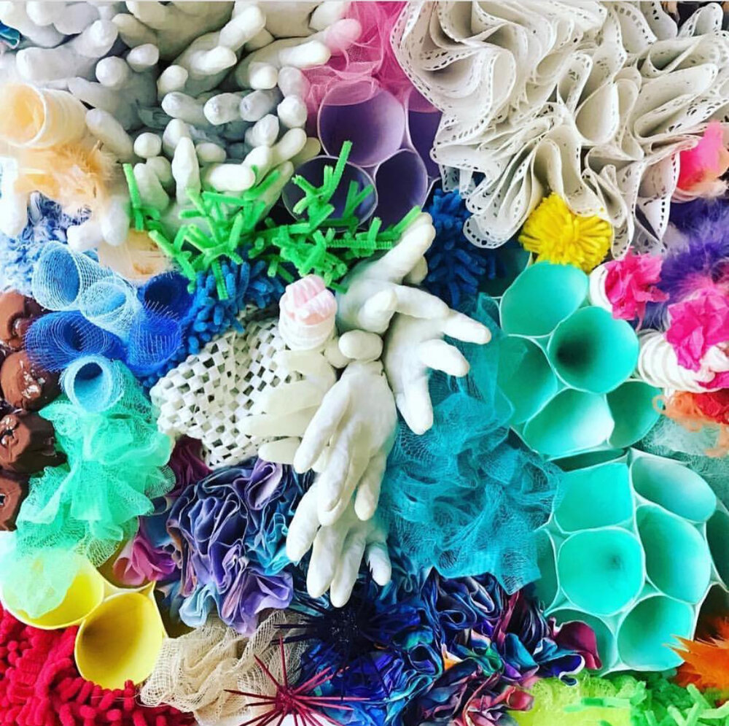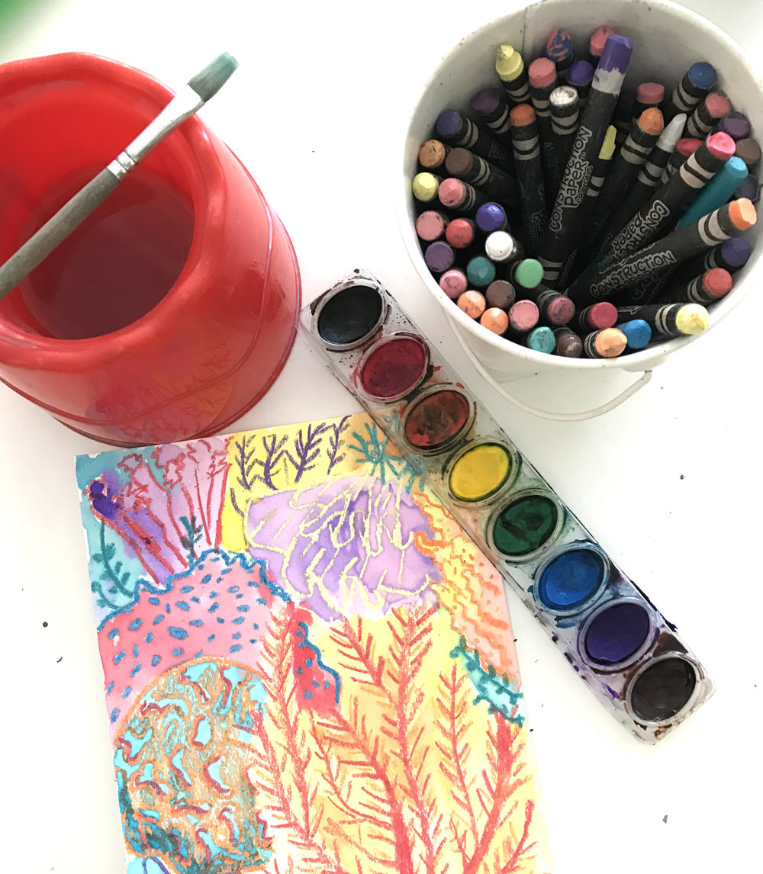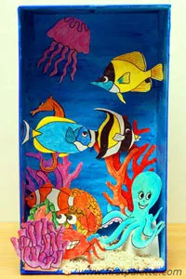

- Can you find out more about nature that glows in the dark. What is this phenomenon called? Why might animals glow in the dark? What glows in the dark on a coral reef? What glows in the dark in the deep ocean?
https://www.youtube.com/watch?v=fYsAK24le6U

Maths
The worksheets for this week can be found on our website. If you need the answers we can also download these and email them - please ask us!
We have chosen to cover number again so there aren’t videos for this topic.
Our focus is addition and subtraction.

Monday -
Introduction - True or False question. 9 + 3 = 11 Let children explain their thinking, ask ‘how do you know? Can you prove it to me etc?’ Many children will think this is true because they don’t count on and go 10,11,12 - they simply go 9,10,11. We call this a maths misconception.
Add by Counting on worksheet: Within the worksheet, Ron and Mo’s problem tries to get the children to notice that you can put the larger number first and count on.
For the last problems children should flip the numbers over and count on from the larger number. (This is the commutative law). If your child likes a harder challenge try writing them like this, 4 + 67, 6 + 36 etc. Put the smaller number first to challenge them to recognise the more efficient method.

Tuesday
Introduction - True or False 7 +3 = 10 so 17 + 3 =20. How do you know? Can you prove it?
Find and Make Number Bonds Worksheet. Use the Mathsbot website if you want tens frames (scroll down to the bottom to find them). https://mathsbot.com/ Bar models are simply another way of representing number problems. You just need to find the missing part to make each bar equal.

Wednesday
Introduction - True or False 5 + 8 is the same as 5 + 5 + 3
Add by making 10 worksheet: There are tens frames on the mathsbot website. https://mathsbot.com/ Question 3 - what they’re getting at here is trying to get the children to realise that if they’re doing 8 + 7, then it’s easier to think of that seven in it’s parts (2 and 5). Then children can add 8 + 2 to make 10 and then add on the 5. This is the kind of thinking that underpins maths fluency. Need to make it harder but develop the same idea? Try 18 + 7 (Do as 18 + 2 +5) or 80 + 70 (Do as 80 + 20 + 50)

Thursday
Introduction - True or False 2 less than 13 is 15 (The language more than and less than can take a while to develop)
Subtraction Not Crossing Ten Worksheet - This is fairly straightforward. If your child needs more of a challenge concentrate on the missing number challenges at the end and talking about how your child is figuring it out.

Friday
Introduction - 13-6 is the same as 13-3-3
Worksheet - Subtraction Crossing Ten. The idea here is to get the children to notice that there are different ways of doing this - see Ron and Eva’s problem. We will return to this idea, for some children it takes them a while to find the most efficient strategy.

Espresso login -

Username - student23524
Password - NR67HL

Phonics

We are now all working on Phase 5, some are just learning the phase 5 graphemes and the others are revising and embedding this understanding in order to be ready for Phase 6 next year.

Espresso login -

Username - student23524
Password - NR67HL

Day | Intro | Teach | Practice | Apply
Monday | Revise the graphemes of your choice.  Find the practice that suits you.  Making your own choices on what to revise, and having an idea of your own personal ‘wobbly spots’ is a really important part of being a learner! | Ash’s phonics on Espresso Phase 5  Watch ay video  OR  Soundalikes  How many graphemes for /ai/ phoneme can you remember? Try to write them down before the end of the video.  (ai, ay, a-e, ey, a)  ey is in they and grey and it is rare!  https://www.twinkl.co.uk/resource/t-l-6332-my-sound-families-display-pack  https://www.twinkl.co.uk/resource/t-t-563-my-sound-family-strip-pack  Choose the format you like best! (You won’t need all of these this week) | Play the games next to the video.  OR  Make collections for the /ai/ family of graphemes. How many words do you know for each one?  https://www.twinkl.co.uk/resource/t-l-54278-alternative-spellings-ai-ay-a-e-table-activity-sheet | Read your reading book and look for ay.  How many did you spot? Where was it in the word?  OR  Make a collection of the words you found for each spelling of the /ai/ grapheme. Where did it sit in each word? Are there any patterns? What’s common and what’s not very common? Did you find any other graphemes that sound like /ai/?
Tuesday | See above - try to start testing yourself to see where your wobbly spots are! Remember this is just part of being a learner - don’t be afraid to face the tricky bits! | Ash’s phonics on Espresso Phase 5  Watch /aw/ video  OR  Soundalikes  How many graphemes for /aw/ phoneme can you remember? Try to write them down before the end of the video.  (or, aw, au) | Play the games next to the video.  OR  Make collections for the /or/ family of graphemes. How many words do you know for each one? | Read your reading book and look for /aw/.  How many did you spot? Where was it in the word?  OR  Make a collection of the words you found for each spelling of /or/ grapheme. Listen carefully! Where did it sit in each word? Are there any patterns? What’s common and what’s not very common? Did you find any other graphemes that sound like /aw/?  E.g. oor, ore etc.
Wednesday | Keep going - see above! | Ash’s phonics on Espresso Phase 5  Watch ea video  OR  Soundalikes  How many graphemes for /ea/ phoneme can you remember? Try to write them down before the end of the video.  (ee,e-e,ea, ey,e) | Play the games next to the video.  OR  Make collections for the /ee/ family of graphemes. How many words do you know for each one?  https://www.twinkl.co.uk/resource/t-l-8645-alternative-spellings-ee-ea-ey-e-e-and-y-table-activity-sheet | Read your reading book and look for ea.  Can you hear the /ee/ sound?  How many did you spot? Where was it in the word?  OR  Make a collection of the words you found for each spelling of /ee/ grapheme. Where did it sit in each word? Are there any patterns? What’s common and what’s not very common? Did you find any other graphemes that sound like /ee/?
Thursday | Keep going - see above! | Ash’s phonics on Espresso Phase 5  Watch /ir/ video  OR  Soundalikes  How many graphemes for /er/ phoneme can you remember? Try to write them down before the end of the video.  (er,ur,ir) | Play the games next to the video.  OR  Make collections for the /er/ family of graphemes. How many words do you know for each one?  https://www.twinkl.co.uk/resource/alternative-spellings-er-ur-ir-ear-or-table-activity-sheet-t-l-9349 | Read your reading book and look for ea.  Can you hear the /ir/ sound?  How many did you spot? Where was it in the word?  OR  Make a collection of the words you found for each spelling of /er/ grapheme. Where did it sit in each word? Are there any patterns? What’s common and what’s not very common? Did you find any other graphemes that sound like /er/?  E.g. ear as in early, earth
Friday | Tricky Word Trucks on Phonics Play  https://new.phonicsplay.co.uk/resources/phase/5/tricky-word-trucks | Test yourself on reading and spelling the tricky words in the phases you have done.  The aim here is to teach yourself what needs more work! | Choose a way to revise your target word.  You could use colours, try to visualise the word, make up a clapping rhyme or do Look/Cover/Write/Check | Write a sentence containing your word for your adult or sibling to read. Get them to write one for you to read.

