Summer Term - Year 1 Week 7 (w/b 8th June)

We hope you have all settled into the new term. We look forward to seeing how you get on with the learning this week. We have been helping the creature for many weeks now and want to thank all the children for their hard work. Hopefully we will soon solve the mystery of where he came from!

lkeatley5nry@nsix.org.uk
jdaubney6qrg@nsix.org.uk
ldavey7wrr@nsix.org.uk
gsmith7xrt@nsix.org.uk

We will email on Monday with information about the weekly story.

Week 8

Inquiry: The Journey Home

Our creature is enjoying all the bright colours of the ocean even though he has not yet found anything that looks quite like him. He has been spending a lot of time with a friendly clown fish. The creature tells the clown fish how colourful and beautiful the Great Barrier Reef is and is surprised when the fish looks sad. “What ever is the matter?” he asks her. The clown fish replies, “You should have been here a few years ago. It was much more colourful then”. This gives our creature a lot to think about.

- Can you find out about the Great Barrier Reef and how it has been changed by pollution?
Pollution is anything that makes the world dirty and unhealthy.
https://www.wwf.org.uk/fight-plastic-pollution
https://www.youtube.com/watch?v=61RzwbaSoeU

- Pollution is not just a problem in the oceans. It is something that happens all over the world. However, everybody can help do something about it. watch this video and do some more research if you would like to. Can you list three ways you could help?

https://www.wwf.org.uk/updates/how-does-plastic-end-ocean There are some tips here, some are for adults but others are for children.

- One of the best ways we can all help the environment is to reduce, reuse and recycle. Can you find out more about this and make a poster to help everyone else remember. Don't forget that posters need to be eye-catching and clear.
BBC Bitesize: What should I do with my rubbish?
https://www.youtube.com/watch?v=Yoqivh3GkaE&disable_polymer=true

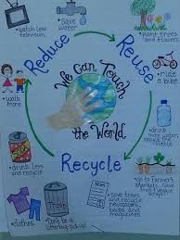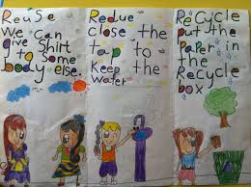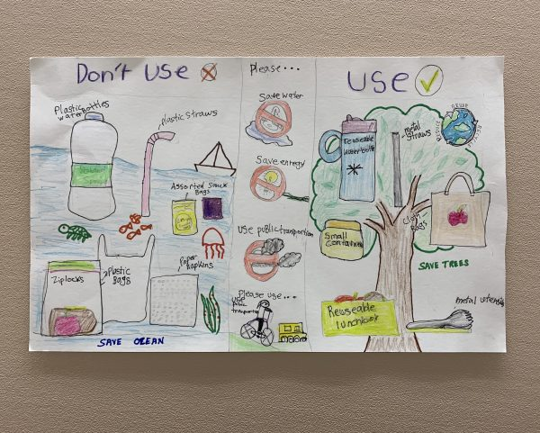

- Do something to help the environment. Maybe you could sort some recycling, pick up litter in your house or make something new out of something old. Maybe you could walk instead of driving somewhere - this will help the environment too. There are so many ways to reuse something! Can you find an interesting way to reuse something? Get an adult to help you if you use the internet. Write a sentence / 3 sentences to tell us what you did.

Maths
This week we are learning the language and skills that underpin multiplication and division.
The True and False tasks are warm up activities designed to help you gauge their understanding before the main lesson. For this week there is a lot of focus on language so encourage them to use the appropriate vocabulary, as found on the sheet.
To continue to memorise the number bonds for 10 (a vital skill to take into Year 2) try singing the Number Pairs Song by Brainzy Games https://www.youtube.com/watch?v=jZi-6_-Uhwc
Spot those number pairs that make 10 everywhere you go e.g. number plates etc. Can you adapt the song to work for another number e.g. 9?
This game can also help when practising number bonds.
https://www.ictgames.com/saveTheWhale/index.html

Monday
Introduction - True or False - There are 40 cakes.
Main activity - Count in 10s. This sheet looks very simple but many children find it tricky to talk about ‘how many in each group?’ and ‘how many groups?’ This is the most important part of the lesson and underpins the understanding behind multiplication and division. Spend as much time as they need on these 2 questions, lego bricks are good for practice.

Tuesday
Introduction - The Groups are Equal. True or False? The four biscuits on each plate are arranged differently but are all 4, so are equal.
Main activity - Make equal groups. This carries on from yesterday - getting the children to use knowledge of how many in each group and how many groups. It begins by challenging children to really look and see if groups are actually equal as they often make assumptions!

Wednesday
Introduction - True or False. There are 2 groups of 5. Although the answer would be unchanged if you think of it as 2 x 5, what you can actually see here is 5 groups of 2, or 2+2+2+2+2. The key for this true or false activity is the correct use of language!
Main activity - Add equal groups. Again this reinforces the use of language and gets the children to record it as repeated addition. (Before you do 2 x 3 times you need to know that is 2+2+2 as repeated addition.)

Thursday
Introduction - This array shows 5+5+5
Main activity - Make Arrays. An array is where objects or pictures are put into a strict grid pattern with equal rows and no gaps. Use counters, lego or pasta to make and talk about all the arrays on the sheet. Try to embed the language of rows and columns.

Friday
Introduction - True or false? The apples have doubled. Children can take a while to gain a firm understanding of the language and concept of ‘double’. Sometimes they think double just means ‘more.’
Main activity - Make Doubles. Lots of lovely doubling practice! Those who find this easy can start to memorise their doubles.

Espresso login -

Username - student23524
Password - NR67HL

Phonics

We are now all working on Phase 5, some are just learning the phase 5 graphemes and the others are revising and embedding this understanding in order to be ready for Phase 6 next year.

Monday | We will be starting off each Day with Tricky Word Trucks to help us revise all of the tricky words.  Grapheme Check  This week we are going to play some games and activities based on the graphemes we find tricky. Go through your phase 3 & 5 grapheme mats and write down which ones you found difficult or didn’t know straight away. Pick 3 graphemes and these are the ones you will use in your games and activities this week.
Tuesday | We will be starting off each day with Tricky Word Trucks to help us revise all of the tricky words.  Noughts and Crosses!  This is one of our favourite games to play in the classroom.  Draw a noughts and crosses frame and write a different word containing the graphemes you are practising in each section.  Take it in turns to pick a word to read. If you get it right you can put your nought or cross in that space. If you get it wrong then your turn passes to your partner. The first to 3 in a row vertically, horizontally or diagonally wins! You can play this a few times with different words.  Can you pick a few of the words you have used today to put into a sentence?  You could always play Picnic on Pluto if you wanted some extra practise.
Wednesday | We will be starting off each Day with Tricky Word Trucks to help us revise all of the tricky words.  Bingo!  Today we will make our own bingo games. Using the graphemes you have been practising this week, find and write down lots of different words containing your graphemes. You and your partner will then need to choose 6 of these words and write them down. Take it in turns to choose a random word, or recruit someone in your family to be the bingo caller, and the first person to cross off all of their words wins. You could play this a few times. The bingo caller could also sound out each word and the players can blend the word to figure out which word it is.  Can you pick a few of the words you have used today to write a silly question?  You could always play Dragon's Den if you wanted some extra practise.
Thursday | We will be starting off each Day with Tricky Word Trucks to help us revise all of the tricky words.  Treasure Hunt!  Using the words you have written earlier in the week or finding new ones, make a treasure hunt. Hide the words around the house or garden and see if you can find them all.  Can you use some of the words you found to write a sentence?  You could always play Buried Treasure if you wanted some extra practise.
Friday | We will be starting off each Day with Tricky Word Trucks to help us revise all of the tricky words.  Real or nonsense?  We often sort words between real and nonsense, just like on our phonics play games. Today we are going to make our own. Can you think of your own lists of nonsense and real words to sort. Real words are treasure and nonsense words go in the bin. You could make your own treasure chest or bin. There are also some examples of the game here: Buried Treasure Game.  Can you pick a few of the words you have used today to put into a silly sentence?  You could always play Picnic on Pluto if you wanted some extra practise.

Have a great week!

