Summer Term - Year 1 Week 5

Hello everyone - nearly made it to half term! We know it’s getting harder for everyone to understand how the next few weeks will look and that your work needs may be changing. Everyone is under so much pressure so please remember that these activities are a guide - just do what works for your family. Stay well and let’s hope for a return to warmer weather.

lkeatley5nry@nsix.org.uk
jdaubney6qrg@nsix.org.uk
ldavey7wrr@nsix.org.uk
gsmith7xrt@nsix.org.uk

Week 5

Thank you for your patience with us around our change of format. Zoom was quite tricky at the beginning too so I’m sure we’ll get used to it! Google Meet Hangouts - 10:30
We will email you the meeting invite, just click on the link!

Day | Teacher
Tuesday | Miss Smith
Wednesday | Mrs Daubney
Thursday | Miss Davey  Miss Keatley

Inquiry: The Journey Home

This inquiry is called ‘The Journey Home’ and is about a mysterious creature. Children will create this creature themselves and then support it on its journey to find its way home.

The creature has enjoyed spending time in the pond but they feel too big to be in this kind of water. They think that they belong somewhere else. Somewhere bigger! Where could the creature go?

- Can you find out about some larger types of water? Where would you find them? What creatures live in them?

Ocean video
https://content.espresso.co.uk/espresso/primary_uk/subject/module/video/item1155321/grade1/module1142775/index.html

- Can you look at different habitats in water, such as the Great Barrier Reef. Where is it? Why is it so special?

- Do you know the names of the different oceans around the world? What are they called? Some animals only live in particular oceans, do you know which live where?

Here are some facts to help you research:

https://www.twinkl.co.uk/resource/t-tp-5976-oceans-of-the-world-facts-powerpoint

And a fun song!
https://www.youtube.com/watch?v=X6BE4VcYngQ

- Here are some ideas of ocean artwork, can you be creative and make some of your own. You could focus on your favourite sea creature!
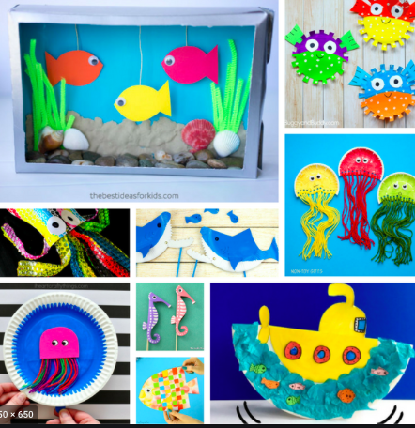
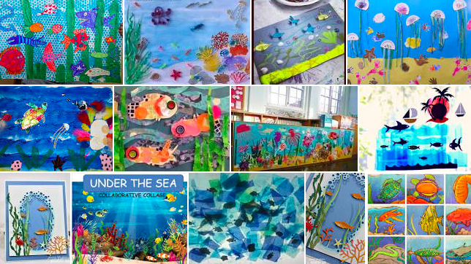

Wednesday would have been Sports Day! We hope you can still join in by having your own mini sports days at home. There will be ideas for this on the website and Facebook group. We look forward to seeing what you all get up to - hopefully the sun will come out!

Maths
The worksheets for this week can be found on our website. If you need the answers we can also download these and email them - please ask us! We are moving on to looking at measures.

The videos can be accessed via this link.

https://whiterosemaths.com/homelearning/year-1/

If you don’t have a printer you can usually just follow along on screen and write your answers down on a piece of paper. The questions in the videos help them practise the skills ready to tackle the follow up worksheet. If the worksheets are too long you can shorten the task!

Here are some games you could play:

The best way to practise length and measuring is by doing it practically but if you would like some online resources to support this then Espresso has lots.

https://content.espresso.co.uk/espresso/modules/search/index.html?source=espresso-home-mixed-topnav-search#/search/length?resourceKey=&subject1Key=&subject2Key=&subject3Key=&keystage1Key=1&sortKey=Relevance

Espresso login -

Username - student23524
Password - NR67HL

Phonics

We have tried to simplify phonics teaching as much as possible! Most lessons have 4 short parts to them. There are 2 main phonics groups for now, please email your teacher if you’re not sure which group they are in. Mrs Bragger’s (group 1) plans will be revising phase 3 as seen in the table below on page 4 and class based (group 2) will be continuing phase 5D.

Starting Phase 5 - Children normally in Mrs Bragger’s group

Espresso login -

Username - student23524
Password - NR67HL

Day | Intro | Teach | Practice | Apply
Monday | https://new.phonicsplay.co.uk/resources/phase/3/flashcards-time-challenge | Mr Thorne Does Phonics ie  https://www.youtube.com/watch?v=bysxOlWkT08 | Buried treasure:  https://new.phonicsplay.co.uk/resources/phase/3/buried-treasure  Choose ie | Write as dictation:  I have pie on my tie.  Look for words containing ie. Where did you find it? Is it easy to find or quite unusual?
Tuesday | The link below explains split digraphs  https://www.twinkl.co.uk/teaching-wiki/split-digraph | Mr Thorne Does Phonics i-e  https://www.youtube.com/watch?v=4-swf3Gy_40 | Picnic on pluto:  Choose i-e  https://new.phonicsplay.co.uk/resources/phase/2/picnic-on-pluto | Write as dictation:  I have a bike and a trike.  Read the sentences:  Don’t play with a kite inside. Take it outside where it can fly high!

Wednesday Sport’s Day Special!
See below
Thursday | https://new.phonicsplay.co.uk/resources/phase/3/flashcards-time-challenge | Espresso oe  https://central.espresso.co.uk/espresso/primary_uk/subject/module/video/item92144/gradef/module63425/index.html | To the side of the video there are 3 games to choose from: sorting graphemes, reading and spelling  Choose an activity | Dictation:  My toe goes red.  Read:  Find words in your reading book - notice that oe is not actually that common! Did you find any?
Friday | https://new.phonicsplay.co.uk/resources/phase/3/flashcards-speed-trials | Mr Thorne Does Espresso o-e  https://central.espresso.co.uk/espresso/primary_uk/subject/module/video/item92160/gradef/module63425/index.html | To the side of the video there are 3 games to choose from: sorting graphemes, reading and spelling  Choose an activity | Write:  I hope you saw my note.  Find words in your reading book. What is more common - oe or o-e?

Phase 5 - Class Phonics

Children have now completed phase 5. This week we will be recapping some graphemes and tricky words.

Monday
Introduce | Today we are going to be practising READING tricky words that we struggle with. There is a mat on the website if you do not have one.
Teach | Go down the tricky word list from the beginning. Read as many as possible. Highlight the first three or four that children have struggled with.  Look at them together. What makes them so tricky to read? Are there any bits of the word that aren’t tricky? Could we think of any ways to make them less tricky (eg some children use “oh- u-lucky dog” to remember the “ould” bit of could would and should).
Practise | On a big piece of paper or whiteboard write these words five or six times but fill the paper with other words (that children do not struggle with). Give them a minute to find and read as many words as possible. Get a point for each word but an extra point for the ones they were struggling with.
Apply | Write some sentences using these words. Make sure the rest of the sentence is decodable.
Tuesday
Introduce | Today we are going to be practising WRITING tricky words that we struggle with.
Teach | Go down the tricky word list from roughly where you think your child is able to write. Write as many as possible. Highlight the first three or four that children have struggled with.  Look at them together. What makes them so tricky to write? Are there any bits of the word that aren’t tricky? Could we think of any ways to make them less tricky.
Practise | In one minute how many times can the child write that word. They can look at the word if they need to but must try and write it at least once from memory
Apply | Write some simple sentences using the tricky words.

Wednesday Sport’s Day Special!
See below
Thursday
Introduce | We are recapping split digraph i-e
Teach | Mr Thorne Does Phonics i-e  https://www.youtube.com/watch?v=4-swf3Gy_40  The link below explains split digraphs if you need more support with teaching these.  https://www.twinkl.co.uk/teaching-wiki/split-digraph
Practise | Play picnic on pluto and pick i-e  https://new.phonicsplay.co.uk/resources/phase/2/picnic-on-pluto
Apply | Write the questions:  Will you invite me inside?  Can I ride that bike?
Friday
Introduce | We are recapping split digraph o-e
Teach | Mr Thorne Does Espresso o-e  https://central.espresso.co.uk/espresso/primary_uk/subject/module/video/item92160/gradef/module63425/index.html
Practise | To the side of the video there are 3 games to choose from: sorting graphemes, reading and spelling  Choose an activity
Apply | Write:  I hope you saw my note.  The stone is under the cone.

Sports Day Phonics
Wednesday is Sports Day so we would like to make phonics active. Can you do one of the following activities:
- Play Phonics Gym - An adult sound talks different activities eg j-u-m-p or s-w-i-m and the child has to blend the word and then act it out.
- Phonics Treasure Hunt - The adult hides graphemes around the house or garden and children race to find as many as possible.
- Phonics splat. - Use chalk to write as many graphemes on the ground outside. Children to have a fly swat (or something similar) and hit the grapheme when you call it out.
- Phoneme tennis - Children have a pretend (or real) tennis racquet. The adult shouts a grapheme out whilst pretending to bat it to the child and the child shouts it back while batting it back.
- Phonics Relay - Write some graphemes/tricky words on pieces of paper. All family members spread out. Person one picks up a piece of paper, reads it and runs to the next person. They read it and take it on to the next person.
- Read and Race games on Twinkl. https://www.twinkl.co.uk/resource/t-l-527007-phonics-read-and-race-game-bumper-activity-pack

Enjoy your week!

