**Hellesdon High School**

**Transition booklet**

**2021**

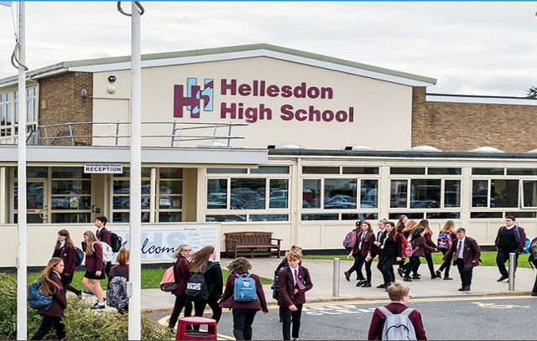

Name: ________________________________________________________

House:

________________________________________________________

Tutor:

_________________________________________________________

**Section 1:**

**Key information**

**The Senior Leadership Team**

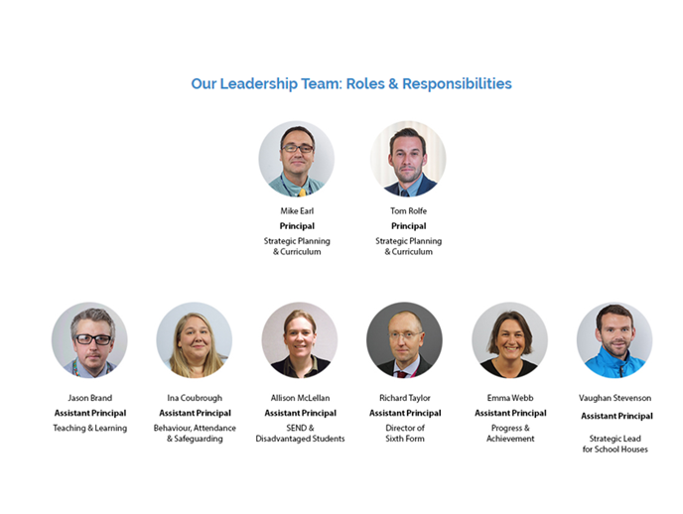

**Heads of House**



Mr Stevenson

Olympus

vstevenson5nrd@nsix.org.uk



Miss Perry-Warnes

Everest

lperrywarn7hrl@nsix.org.uk

Mr Rayner

Fuji

drayner7nre@nsix.org.uk



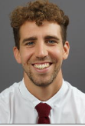

Mr Gardiner

Nevis

mgardiner72r7@nsix.org.uk



Mr Gray

Snowdon

sgray6yr9@nsix.org.uk

**School uniform**

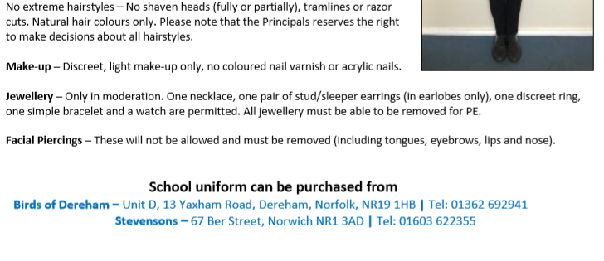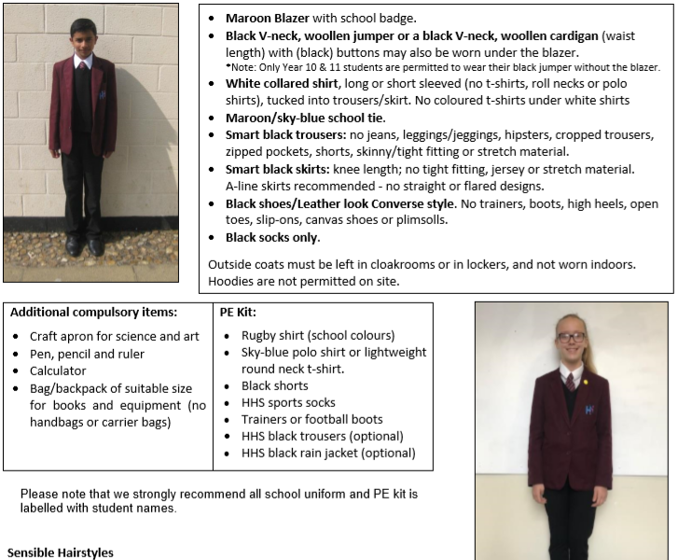

**Making Contact**

If parents/carers wish to speak to a member of staff regarding an issue or query, the lines of communication which are most effective are:

* Email using **principal@hellesdonhigh.norfolk.sch.uk** where your correspondence will be forwarded to the relevant person
* Calling reception to leave a message on **01603 424711.**

If a student is absent from school, parents/carers must call **01603 254333** to report this.

Medical appointments during school hours require a phone call to reception and students will need to be collected by a parent/carer.

Below are key members of our support staff who you may need to contact:

PA to the Principals: **Sharon Revell**

Finance Assistant: **Theresa Lewis**

Administrators: **Sally Bew, Ruth Jewiss**

Pupil Premium & Wellbeing Mentor: **Abby Thetford**

Visitor Reception: **Tracey Nelson**

Student Reception: **Suzanne Richardson**

First Aid: **Hannah Wade**

Pastoral Support Workers: **Mark King, Joanna Cartledge-Lawn, Stuart Bailey, Cherry Greenacre & Louise Rowe**

AIM Supervisor: **Eileen Pinfold**

AIM Support: **Daniel Mullen**

Attendance Officer: **Julie Mollicone**

Designated Safeguarding Lead: **Lisa Vacca**

SENCO: **Allison McLellan**

Assistant SENCO: **Emily Lowe**

**Ways in which the school may contact you**

The school has various methods of communication which ensures we are able to make contact with parents/carers. Staff members may call or email parents/carers directly if needed. The school uses other platforms to communicate to make it easier for parents/carers- these are listed below:

**Class Charts** - a website or app to record behaviour (positive and negative), homework and detentions.

**Sims parent app** - an app to track attendance and assessment

**Scopay** - a website for payment transactions for food, trips or equipment

**Hellesdon High School Website** - this website is continually updated with relevant information and includes a link to all of our school polices.

**Provision Map** – If your child has Special Educational Needs, you will be contacted by our SEND department with a login to review any learning plans and student passports on this system.

Communication from school

Behaviour

Academic

Academic

Attendance

If there is an academic concern your child’s subject teacher or the subject’s Head of Department will make contact with you via phone call or email

If there is an attendance issue (positive or negative) you could be contacted by your child’s tutor, pastoral team, Head of House or our attendance officer

If there is a significant behaviour issue (positive or negative) you may be contacted by the subject teacher, Head of Department, tutor, pastoral team or Head of House. Other behaviour issues (positive or negative) will be communicated via Class Charts

Communication from home

Academic

Attendance

Behaviour

If there is an academic concern you can call reception to speak to the subject teacher or Head of Department. If the issue is across a number of subjects you can call to speak to the Head of House.

If your child is absent you must call the absence line to leave details. If your child has a medical appointment you can call the reception and they will log this. If your child is likely to have a prolonged absence you can call reception to speak to our attendance officer.

If you have a concern about your child’s behaviour you can call reception to speak to their tutor, to inform them of the situation. If this is an ongoing concern your child’s Head of House will contact you to offer support. If the behaviour concern is subject specific you can call reception to speak to their class teacher or the head of department.

At Hellesdon High School our staff are dedicated to supporting you and your child. We strive to do this by building effective relationships with parents/carers therefore, if you have made contact with a member of staff who is willing to provide their direct school number or email address please feel free to contact them regarding any concern.

**Section 2:**

**Transition activities**

**All about you**

Make a one page profile about yourself that answers some (or all) of the questions below, you can add some other interesting facts about yourself too. You can share this with you tutor group in September.

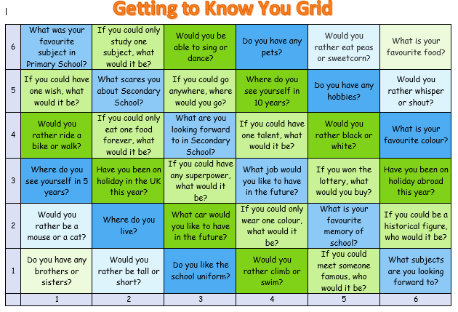

**Going to Secondary School**

**How do you feel?**

These could be useful to find out your feelings about changing school. Use two different coloured highlighters, highlight the phrases that you are looking forward to in one colour; use a different colour for those you are worried about.

|  |  |
| --- | --- |
| Making new friends | Learning a new timetable |
| Lunch time | Detentions |
| Having a different uniform | Being on time |
| Finding way around | Break times |
| Getting to school | Learning new subjects |
| Meeting others my own age | Joining clubs |
| Being with friends | School rules |
| Homework | Meeting my new tutor |
| Meeting my new teachers | Being able to do the work |
| Being with older pupils | Getting changed for sport / PE |

Think about something that worries you about moving to Secondary School.

0 1 2 3 4 5 6 7 8 9 10

|  |  |  |  |  |  |  |  |  |  |
| --- | --- | --- | --- | --- | --- | --- | --- | --- | --- |
|  |  |  |  |  |  |  |  |  |  |
|  |  |  |  |  |  |  |  |  |  |

OK Not OK

What is the worry? _________________________________________________________

_________________________________________________________

On the scale of 0 to 10 how worried are you?  _____

Think of a time when you have been worried before _________________________________________________________

What helped you move down the scale that time?

Where on the scale would you like to feel in a month, 6 months and in a year?

What would help you move one point nearer?

What will have changed so you know you are less worried?

**Hellesdon High School questions!**

**Can you find the answers on our website or by asking current students? Don’t worry if you can’t, we will explain everything in September.**

|  |  |
| --- | --- |
| **Questions about how the School works** | **Answer** |
| What time does School start/ finish? |  |
| What sort of food is sold?  How much do things cost? |  |
| What snacks can you buy? |  |
| How much homework do you get? |  |
| What happens if it isn’t done? |  |
| Where can I do my homework in my free time? |  |
| What happens if I get into trouble?  What are the consequences? |  |
| Who’s the best person to talk to if I am having problems? |  |
| How am I rewarded for my work? |  |

|  |  |
| --- | --- |
| **Questions about getting to School** | **Answer** |
| How will I get to school? |  |
| Can I take a bike?  Where can I put it? |  |
| How much is the bus fare?  Which number bus would I take? |  |
| Are there friends who will be going to the same school I can walk with? |  |
| How long will it take to get there? |  |
| What time will I have to get up? |  |
| Is this better or worse than now? |  |

|  |  |
| --- | --- |
| **Questions about School Uniform and equipment** | **Answer** |
| What do people wear to School? |  |
| Where can I buy it? |  |
| What sports kit will I need? |  |
| Do I need my own pens and pencils? |  |
| What kind of bag will I take my school equipment in? |  |
| Is there any other equipment that I need? |  |

|  |  |
| --- | --- |
| **Questions about Who’s Who** | **Answer** |
| Name of your form tutor |  |
| Name of your Head of House and it’s colour |  |
| Name of the Principal |  |
| Who else do you need to know? What do they do and when will you see them? |  |

|  |  |
| --- | --- |
| **Questions about the timetable and learning opportunities in School** | **Answer** |
| How does the timetable work? |  |
| What subjects will I study? |  |
| What facilities does the School have (e.g. sports equipment, science laboratories)? |  |
| What happens if I find the work hard? |  |
| Is there support in lessons? |  |
| What activities are there after school? |  |
| What other activities are offered? |  |
| Which could I join? |  |

|  |  |  |
| --- | --- | --- |
| **Any other questions I have** | **Best way to find out** | **Answer** |
| 1. |  |  |
| 2. |  |  |
| 3. |  |  |
| 4. |  |  |
| 5. |  |  |
| 6. |  |  |

**Finding your way around**

**(Use the virtual tour to help you)**

It can be difficult to find your way around a new environment.

On the map mark:

* Your tutor room (you will find this out in September)
* The library
* The canteen
* The toilets
* The main office
* Student’s entrance
* Your cloakroom (this is where your locker will be)

The red areas indicate the places that are out of bounds during break and lunch.

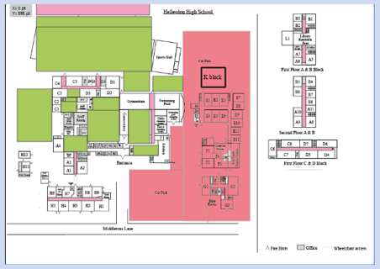

**House system**

The House names:

1.______________________

2. ______________________

3.______________________

4.______________________

5.______________________

My House: ____________________________

My House Colour: ______________________

My Head of House: _____________________

What do you think it means to be part of a house?

____________________________________________________________________________________________________________________________________________________________________________________________________________________________________________________________________________­_________________

There are lots of house competitions across the school year, can you come up with some challenges/competitions that could be run?

_____________________________________________________________________________________________________________________________________________________________________________________________________________________________________________________________________________________________

**School Uniform**

It is important to wear the right clothes when you start at Secondary School.

Find out the school dress code **(HINT – look in section 1 of the booklet)**.

Are there any clothes or jewellery you are not allowed to wear?

_________________________________________________________

Is there anything you need to practice?

* Tying a tie?
* Changing quickly for PE?
* Tying shoelaces?

_________________________________________________________

List some of the clothes you might wear to school.  Remember to think about appropriate shoes.

1. _____________________________________________________
2. ___________________________________________________________
3. ___________________________________________________________
4. __________________________________________________________
5. ___________________________________________________________

Make sure you buy a bag that can hold A4 folders, textbooks, equipment and that is comfortable to carry

You will need different clothing for P.E.  Make a list

You will need different clothing for P.E.  Make a list

1. ______________________________________________________________
2. _____________________________________________________________________
3. _____________________________________________________________________
4. _____________________________________________________________________
5. _____________________________________________________________________

Make sure you buy a bag that is suitable for carrying your P.E. kit, and that is comfortable to carry

**Morning Break**

At the end of a lesson you need to pack your bag, check you have all your belongings and usually you have to leave the room in order to go to your next lesson.  At some time in the morning you will usually have a longer break in which you have time for a snack and to meet up with your friends.

Start time: ____________________

Finish time: ___________________

Length of break: _______________

**Where can I go and what can I do at morning break?**

|  |  |
| --- | --- |
| Place | What you are allowed to do |
|  |  |
|  |  |
|  |  |

**What snacks can I buy at School?**

1. _____________________________

2. _____________________________

3. _____________________________

**Members of staff will be on duty around the school, you can spot them as they will be wearing bright yellow jackets or vests!**

**Lunch Break**

The lunch break is between morning and afternoon lessons.  It is a time when you can mix with your friends, go to a lunchtime activity, and eat your lunch.

Start time: ____________________

Finish time: ___________________

Length of break: _______________

**Where can I go and what can I do at lunchtime?**

Most Secondary Schools have a canteen system or you can bring a packed lunch.

Make a list of some of the different types of food you can buy in the canteen:

1. _____________________________

2. _____________________________

3. _____________________________

4. _____________________________

5. _____________________________

6. _____________________________

**REMEMBER: WE DO NOT ACCEPT CASH**

If you bring in a packed lunch you will need to find out

Where can you eat it?

____________________________________________________

What time do you eat it?

____________________________________________________

Can you buy a drink at school?

____________________________________________________

What sort of drinks or containers are you allowed to bring into school?

____________________________________________________

**Places to go**- there are often different places you can go during your lunch break

|  |  |
| --- | --- |
| Place | What you are allowed to do |
|  |  |
|  |  |
|  |  |

**Members of staff will be on duty around the school, you can spot them as they will be wearing bright yellow jackets or vests!**

**Coping in Secondary School**

Think about how you are expected to behave in school and the reasons for this.

Fill in the chart below.  If you cannot think of some reasons there are some suggestions below.

|  |  |  |
| --- | --- | --- |
| **School expectations**  **(examples)** | **Positives or doing well** | **Negatives for not meeting expectations** |
| Attend classes |  |  |
| Work hard |  |  |
| Ready |  |  |
| Respect |  |  |
| Safe |  |  |

**Section 3:**

**Activities to complete with your parent/carer**

**Morning routine**

Before leaving for School there are a lot of things to think about, starting from the night before.

**Things to think about in the morning.**  Put them in the right order.

* Get dressed
* Check you have the correct equipment in your bag
* Check your timetable
* Wash
* Check you have got your homework
* Clean your teeth
* Say “Goodbye”
* Check you have the correct money
* Wake up
* Eat your breakfast
* Leave for School

Any others?

* _______________________
* _______________________

Plan your morning routine with approximate times.

|  |  |
| --- | --- |
| **Time** | **What to do** |
|  |  |
|  |  |
|  |  |
|  |  |
|  |  |
|  |  |
|  |  |
|  |  |
|  |  |
|  |  |
|  |  |

**Home help**

Show the next 2 pages to whoever helps you get ready for school.

**Ideas for helping your son/ daughter at home**

The most important help you can give is continual encouragement and praise.

**Talk**

Encourage your son/ daughter

* To talk about School- likes/ dislikes, what they are good at, what they are worried about…
* To talk about books, films, hobbies etc.

Don’t pressure them they will talk when they are ready.

**Organisation**

* Encourage them to make a large copy of their timetable
* Display it in a prominent place
* Refer to it to remind them what lessons they have each day
* Make lists of what they need each day
* Encourage them to pack their bag with everything they need for the next day
* Encourage them to check it against the list for that day
* Don’t pack their bag for them
* Encourage them to get into a routine and do things in a similar sequence

**Homework**

* Help plan out extended pieces of homework over a period of days or weeks
* Check their homework diary or Class Charts each day
* Encourage them to have a set time to do their homework
* Help with homework
* Don’t do their work for them
* Keep an eye on the time they spend on their work.  Check they do not spend too long or too little time on each piece
* If your child is struggling with homework write a note for their teacher or contact their tutor

**School equipment**

**Things I need to bring every day**

Every day you will need your writing equipment.  Circle the equipment you need in your pencil case.  Draw in anything else you need.

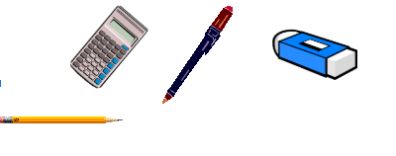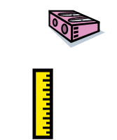

**How are you getting to school and back home?**

|  |  |  |  |
| --- | --- | --- | --- |
| Mode of Transport |  | How long does it take?  (Minutes) | Can you meet friends on the way? |
| Walk |  |  |  |
| Bike |  |  |  |
| Car |  |  |  |
| Public bus |  |  |  |
| School bus |  |  |  |

What if you want to do extracurricular activities?

At Hellesdon High School, we have a wide range of extracurricular activities that run every day after school and are all free!

If you bike to school your bike will stay safe in the bike shed, if you get a school bus we have a late bus which collects pupils at 4pm every day. If you get a public bus, check for later times.

Or have a detention?

If you have a detention you can check when this is using Class Charts to organise how you will get home, all detentions finish in time for the late bus.

How to tell your parent or carer you are going to be home later than expected?

You are not allowed to use your mobile phone at school so if you want to contact home you will need to visit your Head of House at break or lunch time to call home.

**Behaviour/ Rewards/ Homework/ Detentions/ No Excuses**

At Hellesdon High School we use a website called Class Charts to record and report to parents/carers, behaviour (positive or negative), homework, detentions and no excuses marks.

No excuses is our behaviour policy outside of the classroom to ensure all pupils are ready, respectful and safe. If pupils accumulate no excuses marks this will result in detentions.

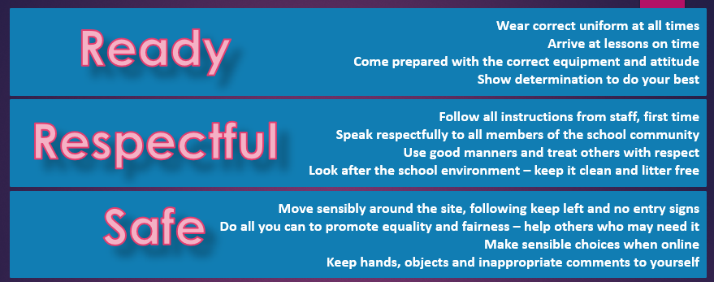

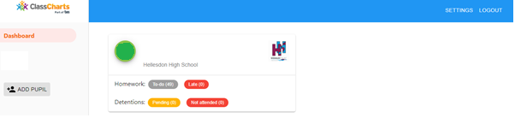

**Assessment**

To communicate assessment and attendance we use the Sims Parent App. Assessment grades will be uploaded at calendared times of the year when school will notify parents.



Along with the assessment grades will be Attitude to Learning grades which are summarised below.

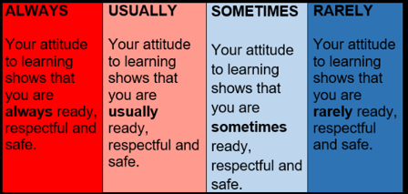

Any questions regarding assessment should be directed to the Head of Department or the specific teacher.

**Reading a timetable and finding your way around school**

Below is an example of a Y7 timetable, on the map on the next page, draw a line that shows how you will get from lesson 1-2, 3-4 for each day. Use a different colour for each day.

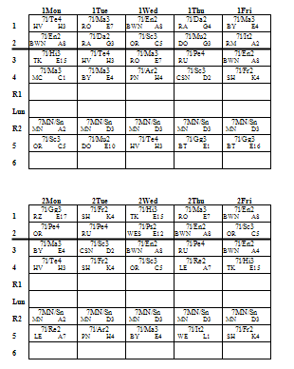

Subject code

En = English

Week number and day

Monday week 2

Teachers initials (BWN)

Room number (E4)

Lesson number (1)

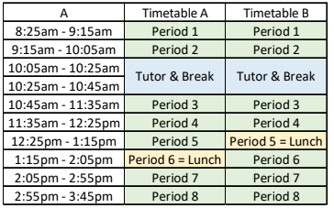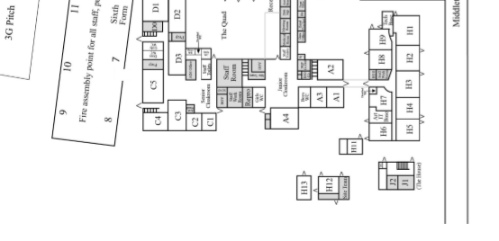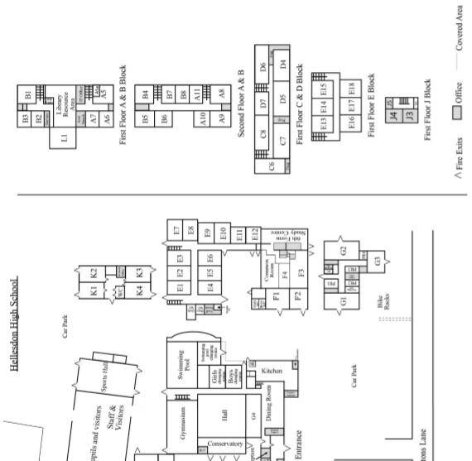

**Section 4:**

**Tutor activities**

**You can read through this section and attempt some of the tasks, tutors will look at this section with you in September.**

**Friendship skills**

Choose the right word to match the definitions.

advocate disagree trust respect empathy confidential

compliment advice command secret support apologise

1. ____________________ an opinion or recommendation you make about what someone should do

2. ____________________ to say you’re sorry for something you said or did

3. ____________________ private or secret

4. ____________________ someone who defends and supports you

5. ____________________ to have a different opinion from someone

6. ____________________ to say something nice about someone

7. ____________________ information that’s not meant to be shared with others

8. ____________________ to stand behind or encourage others

9. ____________________ understanding what someone feels

10.____________________ to rely or have confidence in someone

11.____________________ to hold someone in high esteem

12.____________________ a direct order to do something

**How to be a friend**

Here are some positive things friends do for each other to keep their friendship strong.

* **Empathise**. Put yourself in your friend’s situation to understand what they’re going through.
* **Support**. You can show your support for your friends by just listening when they want to share.
* **Compliment**. Everyone likes to receive a compliment.  Compliment your friend on a new hairstyle, a great score on a test, a smooth football move.  Be specific and keep it simple.  Choose the right moment to give the compliment.
* **Respect privacy.** Sharing secrets is a fun part of a friendship.  It’s hard to regain your friend’s trust if you tell secrets you weren’t supposed to share.
* **Encourage.** Use encouraging statements like, “You can do it”.

When you wonder if you are being a good friend, ask yourself this question:



My friend looks unhappy

Are you ok?

**Am I treating my friend like I want my friend to treat me?**

**Making new friends**

At Secondary School there are likely to be students from other schools.  There will be opportunities to make new friends.  It can be difficult to get to know someone new.

It may help to act out meeting new people and use some of these suggestions.

* Smile when you say “**Hello**”.
* Start the conversation by asking a question about what they are doing “**What are you doing?**” or “**What are you reading?**” or about something you have in common “**So how do you like this lesson?**”
* Introduce yourself “**By the way my name is ______________, what’s yours?**”
* Ask some other questions to find out about them.  Suitable topics may be:

School: **Who is your teacher?**

Home: **Where do you live?**

**How do you get to School?**

Interests: **What do you like doing?**

**What’s your favourite TV programme?**

Family: **Have you any brothers and sisters?**

If they answer your question respond to some of the information they have told you.  If you can, ask another question. “**That’s my favourite lesson too.  I enjoyed working on the computers.  What did you like doing?**”

* Do not ask about sensitive topics.  These are topics that could make the other person upset.
* Don’t ask about something that makes the person look or sound different.
* Don’t ask about any problems he or she may have.

**Teasing and Sarcasm**

**√**

**√**

**Some teasing is done in good-natured fun,** but when teasing gets out of control it can be hurtful. Before jokingly teasing a friend, ask yourself these questions:

Is this an okay subject to tease someone about?

Will my friend understand that I’m teasing?

Have I been teasing my friend a lot lately?

Will this get on my friend’s nerves?

**If you are teased and you don’t like it,** resist the urge to hit or push your friend. You can ignore the teasing and simply walk away, or you can respond to the teasing by trying to diffuse the situation. Try making statements like these:

* “And your point is…?”
* “I’ve heard that one in primary school”
* “Tell me when you get to the funny part”
* “Can’t you think of anything important to say?”
* “I’m sorry, were you speaking to me?”

**Sarcasm can be a form of teasing.**  The words in this kind of teasing are nice, but the way the words are spoken adds to the teasing or sarcasm. When you use nice comments to be sarcastic, you exaggerate the expression in your voice and on your face. Say each phrase on the left in a sarcastic tone to show the meaning on the right.



That’s an awful haircut!

Nice hairstyle!

“Yeah, whatever” means: You are not bothered

“Ah well done” means: That’s stupid

**Before you tease someone, ask yourself this question:**

Am I treating this person the way I would like to be treated?

**Joining-in**

Joining in conversation or a group activity can be scary. However, it is one way to make new friends. Try these strategies for joining in.

**Watch and listen.**



Observe what the group is doing.

Listen to what the people are saying. Don’t interrupt.

j0336476**Make a friendly comment or gesture.**

Nod your head and smile.

Make comments like, “That’s a good idea”, or “That looks great”.

j0240575**Find something you have in common with the group.**

Think about your own experiences. You could say,

“I saw that movie”, or “I have that game at home”.

Keep your comments short.

j0297489**Ask to join the group.**

Wait for a pause in the conversation.

You could say, “Can I walk with you?”

“Do you need any help?” or “Can I play?”

**Accept ‘no’ for an answer.**

Sometimes people don’t want you to be part of the group.

Don’t argue or complain. Go and ask someone else.

j0343313

**Joining-in Situations**

Here are some situations you might want to join in with. Try and plan what you may say or do. You could try acting these situations out.

1. You see three of your classmates playing football after school. You know one of them pretty well. You don’t know the other two. You’re quite good at being in goal.

What could you do? __________________________

What could you say? __________________________

1. You hear two classmates talking about the latest PlayStation game. You were playing on it last night.

What could you do? __________________________________

What could you say? _________________________________

1. Two classmates are asking the teacher for permission to work on an art project during lunch hour. Art is your best subject and your project is already on display.

What could you do? __________________________________

What could you say? _________________________________

**Being with friends**

Sometimes you have to think carefully about how you act with different people and whom you can share information with.

**Getting it right**

It is important to behave differently with different people.

Using the concentric circles sheet, work out who you would act in these ways with. You may choose more than one group of people.

* 1. Who would you hug?
  2. Who would you use swear words with?
  3. Who could you tell what to do?
  4. Who can you argue with?
  5. Who can you share your sweets with?

Make up your own:  ___________________________________________________

**Sharing information about yourself**

It is important to talk to people to share an event, achievement or tell them about a problem. Sometimes you have to be careful whom you talk to. Some people may tease you if you are not good friends or they may not keep the information to themselves and share it with others.

Who would you tell these things to? Use the concentric circles to decide who you would share the information with.

1. You still cuddle your teddy at night.
2. You fancy the girl or boy next door.
3. You have won a competition.
4. You have not done your homework.
5. You hate peas

**Concentric Circles**

Anyone

No

One

Family

Friend

Teacher

**Sharing information**

Sometimes friends will tell you information. It can be OK to tell other people some bits of information. Other information you should tell no one, these are considered to be secrets.

It can be tempting to share secrets, but think:

* How will my friend feel if I share this secret?
* How will this affect our friendship?
* How would I feel if my friend shared a secret like this about me?

Who could you tell these things to?

1. Your friend says that they like Sam.
2. Your friend says their Dad is in jail.
3. Your friend says they are going to watch a film tonight.
4. Your friend says they hate wearing school uniform.
5. Your friend says he smokes.

Make up your own:  ______________________________________________

Tell a friend

Tell anyone

Tell no one

**Facts about bullying**

**Bullying:**

* Is any behaviour by an individual or a group that deliberately harms another person.
* Can be physical or involve threats of physical harm.
* Can be name-calling or spoken teasing.
* Can be demanding money of things, or making someone do something they do not want to do.
* Can involve excluding someone (deliberately leaving someone out of an activity, ignoring them etc.)
* Is usually repeated over a period of time.
* Takes place when one person or group has more power than the person or group being bullied.

**Bullying is not:**

* An accidental bump or jostle, in the school corridor, for example.
* An argument with a friend.
* A friend being nasty over something specific.
* A one-off fight or argument.

**Why do people bully?**

* Very few people who are happy with themselves bully others
* Sometimes bullies have been bullied themselves - they are looking for someone to take their anger out on.
* Sometimes bullies are jealous.
* Bullying can make people feel strong, respected and powerful, but they often feel bad too.

**What to do about bullying**

**What can you do if you are bullied?**

* Keep being positive; say positive things about yourself and other people.
* Be proud of who and what you are (we all belong to different groups and are all equally valuable).
* Don’t keep it to yourself: Always tell someone- a teacher, a parent or another adult.
* Think about the consequences of the different ways you might deal with bullying.
* Some ways of dealing with it are:-
* Ignoring it or staying relaxed, fogging (see next page)
* Being assertive- using your body language, eye-contact, tone of voice, words you say.
* Remember why people bully.

**Six good reasons to tell:**

* You have the right to live without the stress or fear of being bullied.
* Taking action is better than doing nothing.
* There is nothing embarrassing about being bullied - think how many people it happens to.
* It is braver to tell than to hide it.
* If you think there is something wrong with you, is it because the bullies have made you feel this way?  This is a common effect of being bullied and **IT IS NOT TRUE**.
* Bullying does not say anything about **YOU**. It says a lot about the **BULLY**. (If you call me a hippopotamus does it mean that I am one?)

**Creating a Fog**

Creating a ‘Fog’ is a technique that you can use if you feel you are being bullied.

* Remind yourself that the bully has said this to many other people - what they say tells us more about the bully than about you.
* The bully wants to see your reaction - don’t give them that satisfaction.
* Imagine a huge cloud of fog around you that swallows up insults so that they cannot affect you.
* Use a normal bored-sounding voice.
* Say something neutral:
* “Yeah, whatever”
* “If you say so”
* “Well, you could be right”
* “maybe”
* “Ummm”
* “Yes that’s true, I do wear glasses”
* Make sure your body language, tone of voice and the words you use all give the same message:

**‘I’m really not bothered by anything you say or do’**

**Stick with it.** It might not work the first time.

**Make sure you report it to a member of staff!**

**Asking for help**

Sometimes at school things may be difficult or may go wrong.  These things could be small like not knowing what the homework is or not being able to find your way around or could be bigger like getting into trouble or finding the work hard.

There are many people who can help you, but they won’t know that you need help unless you tell them.

**Friends:**  Ask friends or other students if you don’t know where to go.  You can ask them what the homework was if you are not certain.  They can also help to work out new situations like going to the cafeteria.

**Teachers**: Ask your teachers if you don’t know what to do in class or for homework.  They will also be able to help you if you have forgotten something or don’t know where to go.

**People at home**: People at home will be able to help you plan and organise your equipment and homework.  They will want to know if you have any problems.  They will be able to help you work out the best person to ask if you have problems with work or may try and contact someone in school and ask them to help you.

Try and work out whom you would approach in these situations:

* You don’t know where your next lesson is.
* You cannot read your homework notes.
* You have got into trouble for forgetting your course book several times.
* In the lesson you did not understand what the teacher wanted you to do.
* You have not got a pencil which is needed to complete your work.

**REMEMBER TO ASK FOR HELP!**

**Saying sorry**

If you do break a school rule or behave in a way that upsets or hurts someone then you can show you are sorry by apologising.  Sometimes this can be hard as it can be difficult to admit that you are wrong.

Here are some examples of times when you may need to say sorry.

**When you forget something**

* If you forget something, it is not a big problem.  Everyone forgets things and it is always a good idea to say you are sorry.
* Imagine you have forgotten something.  Practise saying the right words with a partner and then it will be easier when it does happen.

For example:

“I am sorry Sir / Miss.  I’m not used to my timetable yet and I’ve forgotten to bring the right book.  I will remember it for the next lesson.”

**When you make a mistake**

* Mistakes can sometimes happen because you did not really understand what the teacher meant.  Some things may be different from what you are used to and if you pretend that you understand when you don’t the teacher will not know that you need help.
* Think up a situation in which you have not understood exactly what the teacher meant and discuss this with a partner.  Take turns to explain to the teacher what has happened.

For example:

“I am sorry Sir / Miss, I have been listening, but I don’t understand.  Please could you tell me again?”

**Settling into Secondary School**

**(and how to solve the problems you might face)**

Sometimes something can happen at school that makes you feel upset or anxious.  A lot of people feel like this especially when they are starting somewhere new.

* **Keep calm.**  Tell yourself, “I can solve this problem if I stay calm.”
* **Decide what the problem is.**

- Are you frustrated because you could not do something you wanted?

- Are you upset because someone did something to you?

- Are you worried because something has gone wrong?

* **Think about possible solutions.**
* **Think about the consequences.**  What will happen if you try different solutions?
* **Pick the best solution.**

Talk with a friend about what you would do in each of these situations in school.

1. You haven’t done your homework.

2. You have forgotten your student planner.

3. You are in a crowd going upstairs and you think someone pushed you.

4. You think you are lost.

5. You see someone being bullied.

6. You find someone crying in the corridor.

7. You’ve lost your purse/ wallet.

8. You see someone stealing money from someone’s bag.

9. You find someone’s purse.

10. You’ve ripped your trousers/ skirt.

**Any further questions?**

Write any other questions you have here, you can ask your tutor in September.