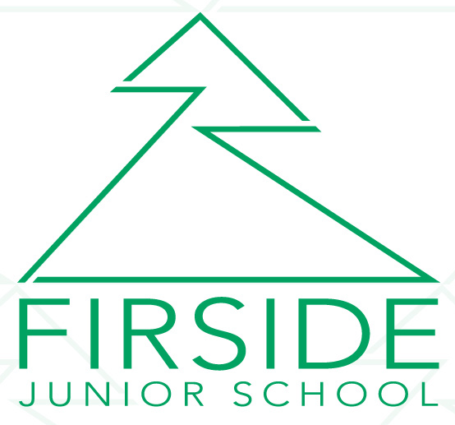
Middleton’s Lane, Hellesdon
Norwich, NR6 5NF
Tel: 01603 426550
Fax: 01603 403361

Headteacher: Mrs R Robinson

www.firside.norfolk.sch.uk
office@firside.norfolk.sch.uk

Friday 1 May 2020

Dear Parents

I hope that you are all well and coping with challenges that lockdown bring to us all. I also hope that home schooling is not to challenging for you. I completely understand the challenges it presents to all parents. I personally dread helping my son with Year 9 Maths every day; but we do it and have a real sense of achievement each day when he completes his tasks.

At the moment, I have no further news on when school will be reopening. As soon as I have any news I will let you all know. In the meantime, please stay safe and look after yourself and your family.

Regards

Mrs Robinson

Keeping In Touch
Over the next two weeks, the teachers will be calling every child in their class to catch up with them and have a chat. They will also have a chat with you and ask if you require any further support from the school. As some of the teachers are working from home, they will be using their personal phones to make these calls. Following current safeguarding guidelines, they will be withholding their number when they call you. Please do not be alarmed if you see a withheld number call your phone; it may well be your child’s class teacher. We will try or best not to call the same household multiple times in one day, but if we do please bear with us.
When the class teacher calls, they do have a number of set questions that they have been requested to ask you. Please rest assured that we are not prying; we are just trying our best to support you and your family in this very unique situation we all find ourselves in.

Important for Parents - Nintendo Switch Hack
Nintendo have confirmed a data breach which means that over 160,000 accounts have had their details stolen, some of these accounts have already been used to make illegal purchases. Nintendo have stated they will contact affected users. It is recommended that you do the following;
- Log in to your Switch account and change the password, remember to use a good, strong password.
- Enable 2-factor authentication. This means that if somebody tries to user your login details, you will get a code sent to your phone, so you know that somebody is trying to log in.
- Go to the HaveIBeenPawned website and put in your username/email address to see if any accounts have been hacked.

