  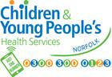
  

Family Health MOT

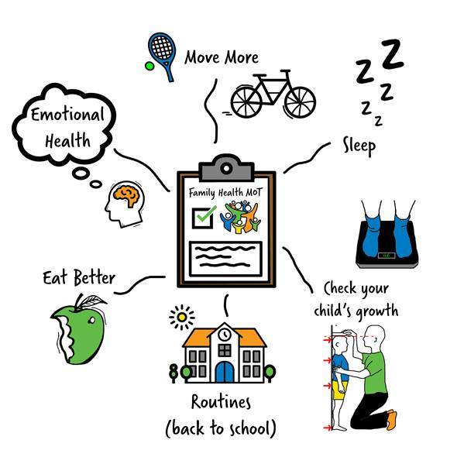
CLICK HERE

To find out more call Just One Number on 0300 300 0123

Facebook

Twitter

Instagram

Vimeo



