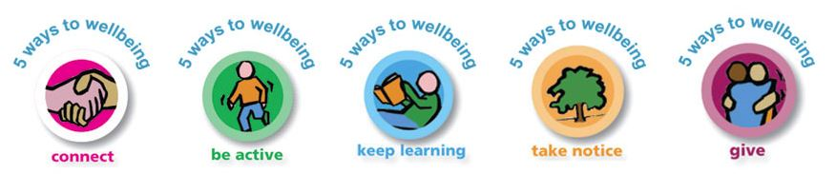
Extra Information Sheet

Memory Game: collect between 10 – 15 different items from around the house (toothbrush, spoon, sock, pencil, etc..) Put them all together. Give yourself 30 seconds to look at everything. Then cover them over with a towel or cloth, try and remember as many items as you can
Smiling Challenge: Face your partner (this could be your grown-up at home or your brother or sister) Have a serious face! See who can stare the longest without smiling or laughing. It gets harder the more you play it!
Den Building: Try and build a den either inside; you can use 2 chairs and some blankets. Hang the blankets over the chairs to make a den underneath. You can also try using a broom. Outside, hang a sheet over the washing line, use a broom or be creative and see what you can make.
Bubble Blowing: Make up a bubble mix by mixing washing up liquid and some water together. You can make a bubble blower out of pipe cleaners, cutting up straws into smaller pieces and threading a string through them or cardboard tubes (these do get soggy though) You could also try sock bubbles! You can use a small piece of cloth instead of a sock and put elastic around it to keep it in place. Dip the end in the bubble mixture and blow gently into the top of the bottle and see what happens
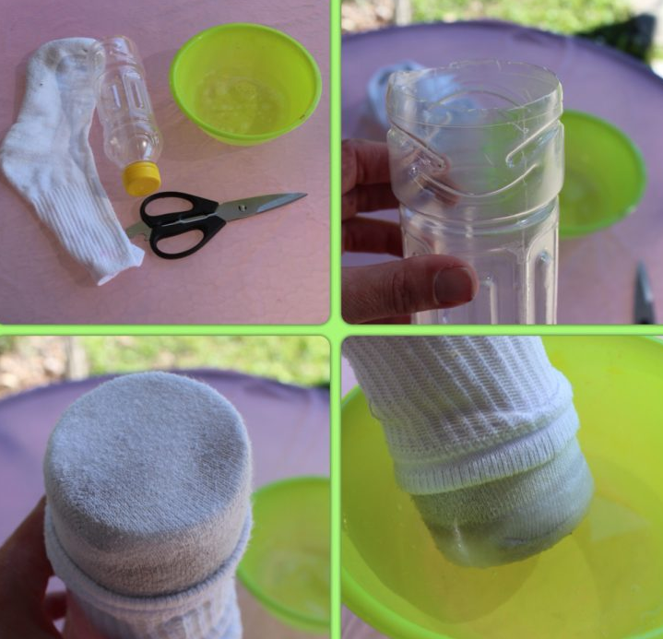

5 Deep Breaths: Sit somewhere quiet. You can do this by yourself or with someone else. Be still for a few minutes. Close your eyes if you want to. Listen. Hear your breathing. Sit up tall and straight. Take a deep breath in through your nose, hold it for a few seconds then very slowly breathe out through your mouth. The air should feel warm. Do this 5 times. Practise it when you first get up or when you feel like you need to calm down and give yourself and your brain a little rest.

Hand and Foot Co-ordination Game: Either print out copies of the hands and feet, or draw around your hands and feet (remember to do left AND right) When you have done this quite a few times, mix them all up and then lay them down on the floor. Put 3 in a row and keep making lots of rows until you have used them all. You might want to stick them down with cellotape so they stay in place. Now the fun starts! Try and complete the challenge as quickly as you can without getting it wrong, if you do get it wrong go back to the start. Good Luck 😊

