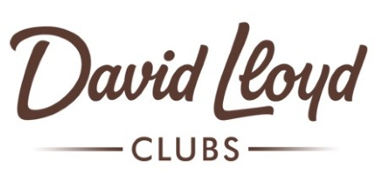


Schools Out Party!
With Chilly`s party time!
Thursday 22nd July
17:30-19:30
Non-members welcome
£7.50 per ticket
Party games
Buffet
Book at reception!

