Tricky words
all | is | she | after | clothes | hour | path
are | little | so | again | cold | kind | people
ask | love | some | any | could | last | plant
be | me | the | asked | door | looked | poor
by | my | there | bath | even | many | pretty
come | no | they | beautiful | every | mind | should
do | of | to | because | everybody | money | sure
friend | once | today | behind | eye | most | their
full | one | want | both | fast | move | told
go | our | what | break | father | Mr | though
has | pull | was | busy | find | Mrs | through
have | push | we | called | floor | old | water
he | put | were | child | gold | only | wild
here | said | where | children | grass | other | what
his | says | why | Christmas | great | parents | who
house | saw | you | class | half | pass | whole
I | school | your | climb | hold | past | would

Can you read all of these words?
Can you spell all of these words?
Pick some of the words and write them in a sentence.
Fantastics
We have been using the Fantastics to help us think of ideas for our writing.
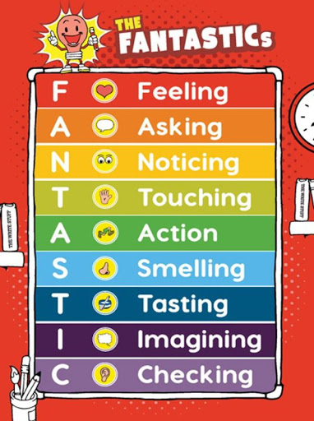
Look at these different locations and write a description of one of them using some of the Fantastics to help you:
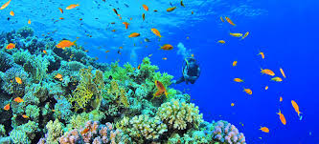
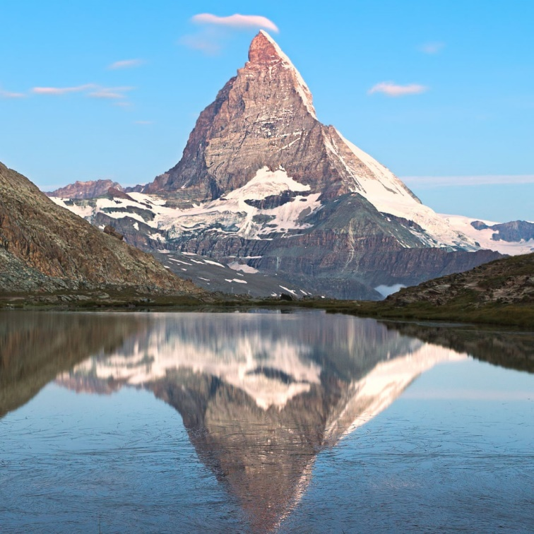
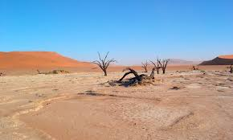

Or you can choose your own location and find a picture to write about.
You could create a character that lives in one of these places and write a story about it.

Keep reading! It doesn’t matter if it is not your school reading book – you can read anything you have at home eg magazines, recipes etc. Talk to someone in your family about what you have read. Tell them which characters you liked or didn’t like. What happened in the story? What was your favourite bit?

Maths
We have been learning our number bonds to 10 and 100 and seeing how they are related.
(1 + 9 = 10/ 10 + 90 = 100)
See how quick you are at recalling the facts – you could use https://www.topmarks.co.uk/maths-games/hit-the-button

Addition and subtraction using 10s and 1s – adding onto 2 digit numbers
(23 + 3 =/ 45 + 30 =/ 45 – 20 = 25/ 47 – 4 = 43)

Partitioning – choose a 2 digit number – how can you split it into different combinations of tens and ones?
(63 = 60 + 3/ 50 + 13/ 40 + 23)

Can you make a word problem related to any of the above?
(At my birthday party, there were 23 balloons, my friend bought me 20 more, how many are there altogether?)

Fact families
Choose a 2 digit number
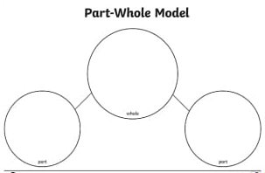
Can you write the 2 digit number in the top circle, and the tens and ones in the circles below. Record the 8 number sentences in the fact family.

Art
Collect some leaves from the garden. Practise your sketching skills and make some observational drawings. Find out the name of the tree that the leaves came from.

Phonics

Make sure you know all of these graphemes. Can you spot some in your reading book? Choose a grapheme and find objects around your house that have this grapheme in.



