Year 1 home learning

Maths

Count from zero up to 100. Then count on from any number (e.g. 26)
Read and write numbers up to 10, then 20, then 50 then 100.
Use https://www.topmarks.co.uk/learning-to-count/paint-the-squares so children can count and see the numbers at the same time.

Form numbers correctly
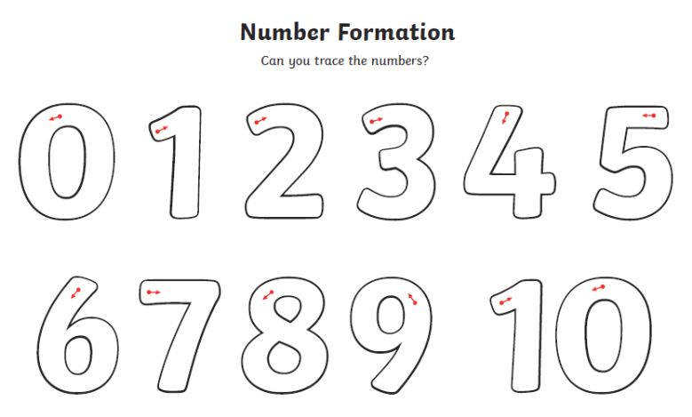

Name and recognise common 2D shapes. Talk about their features. How many sides? How many corners?

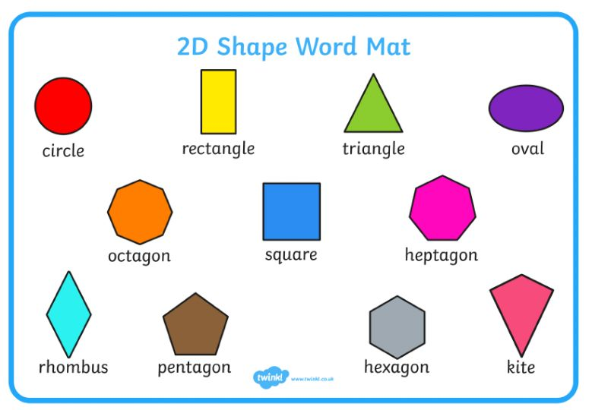

Look for shapes around your house. What can you find? Can you draw a picture using different shapes?

Create repeating patterns using objects or colours. Use lego bricks, paint spots, beads strings or anything at all.
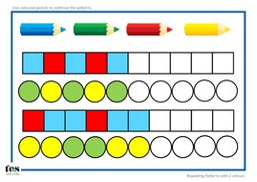

Recall number bonds to 10
Listen to the song...http://https://www.youtube.com/watch?v=poJmS5iWfEs
Play this game... https://www.topmarks.co.uk/learning-to-count/teddy-numbers
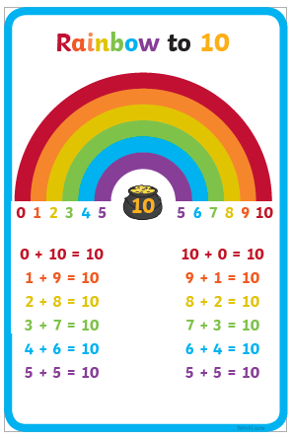

Add two numbers together by putting the largest number in our head and counting on.
What's 5 + 2? Put 5 in our head and count on 2. 5 - 6 - 7.
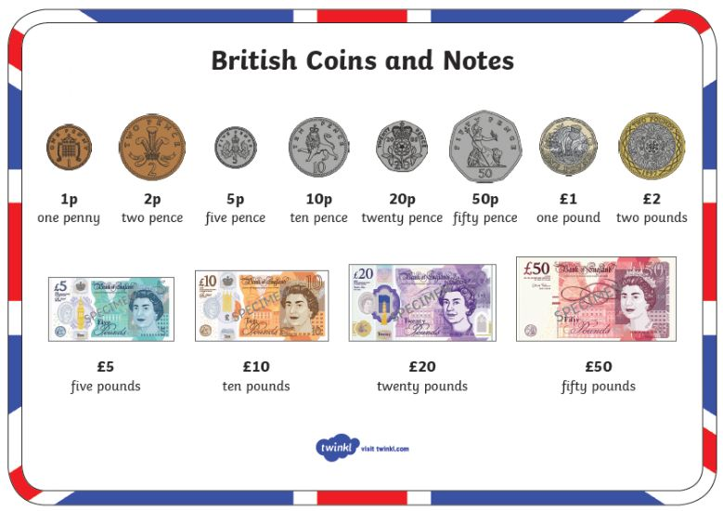

Recognise coins and play shops

English

Write for name with a capital letter at the start and the rest with lower case letters
Writing simple words with all the sounds i.e. frog, black, chip
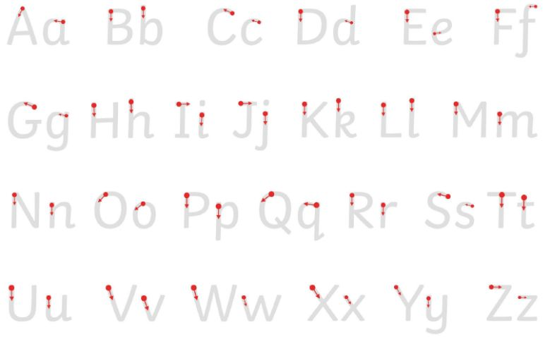

Say simple sentences using these words (from above). Say the sentence and count the words.
E.g. The frog is green.
Support your child when writing simple sentences. Show them the sounds and letters they are unsure of.
For example-
I like fish and chips.
My name is Troy.
I have got a dog.

Read a story and retell it. Can you make props or puppets to help with this?

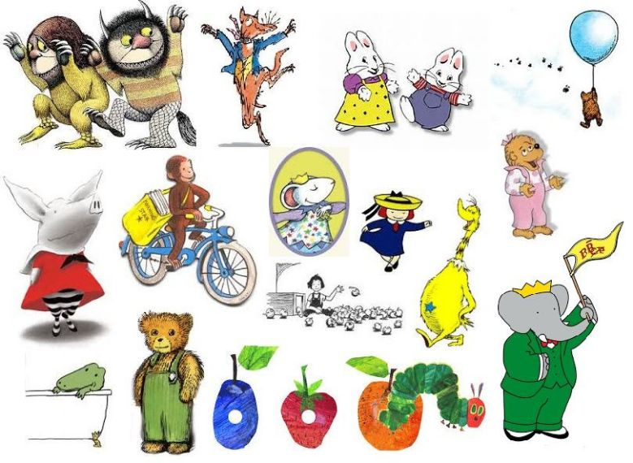

Learn 2 new phonic sounds. Read and write simple words containing the sounds.
Phase 3 sounds:

ch  (as in chip) | sh  (as in shop) | th*  (as in thin) | th*  (as in then)
ng  (as in ring) | ai  (as in rain) | ee  (as in feet) | igh  (as in night)
oo**  (as in book) | oo**  (as in boot) | ar  (as in farm) | or  (as in for)
ur  (as in hurt) | ow  (as in cow) | oi  (as in coin) | ear  (as in dear)
air  (as in fair) | ure  (as in sure) | er  (as in her)

Phase 5 sounds:

a-e  (as in came) | au  (as in Paul) | aw  (as in saw) | ay  (as in day)
e-e  (as in these) | ea  (as in sea) | ew  (as in stew) | ew  (as in chew)
ey  (as in money) | i-e  (as in like) | ir  (as in girl) | o-e  (as in bone)
oe  (as in toe) | ou  (as in out) | oy  (as in boy) | ph  (as in Phil)
u-e  (as in June) | u-e  (as in huge) | ue  (as in clue) | ue  (as in due)
wh
(as in when)

Links to other phonics games and learning ideas.
https://www.phonicsbloom.com/
https://www.phonicsplay.co.uk/

Quickly recognise and read Year 1 tricky words
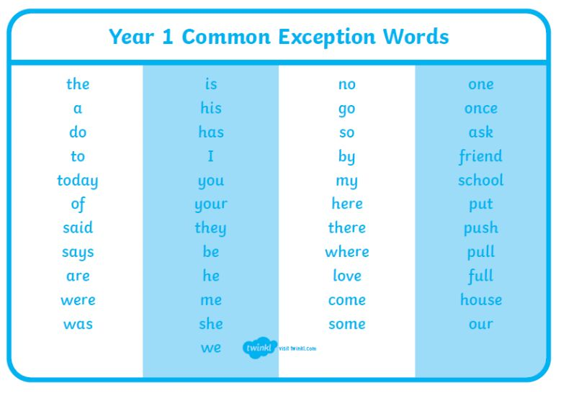

Read something every day.
Draw a picture of your favourite book characters.
Practice fine motor skills to support handwriting such as-
playing with play dough, threading, cutting with scissors, weaving, building Lego.


