
NAME

"All the world's a stage, and all the men and women merely players"

'As You Like It'
William Shakespeare
GCSE
DRAMA COURSE BOOKLET
Everything you need to know to succeed in
AQA GCSE DRAMA

Contents
- Welcome Pg. 3
- Overview of the course Pg. 4
- Component 1: Understanding Drama
  - What is it? Pg. 5
  - Section A Pg. 5
  - Section B Pg. 5
  - Section C Pg. 7
  - Blood Brothers - Notes structure
- Component 2: Devising Drama
  - What is it? Pg. 11
  - Devising Log Pg. 11
  - Section 1: Reponse to a stimulus Pg. 12
  - Section 2: Development and collaboration Pg. 12
  - Section 3: Analysis and evaluation Pg. 13
  - The Devised Performance Pg. 14
  - Statement of dramatic intentions example Pg. 15
  - Assessment criteria Pg. 16
  - Writing the Devising Log Pg. 19
- Component 3: Texts in Practice
  - What is it? Pg. 23
  - Assessment criteria Pg. 24
- Live Theatre Pg. 25
  - On the day & After the performance Pg. 25
  - Instructions Pg. 26
  - Framework Pg. 26
- Writing Pg. 32
  - Descriptive vs. Reflective Pg. 32
  - Sentence starters Pg. 32
- Vocabulary Pg. 34
  - Key vocabulary Pg. 34
  - Adjective bank Pg. 37
- AQA exam material Pg. 39

Welcome to GCSE DRAMA.
You are embarking on a three year GCSE in Drama and this handbook has been created to help guide you through your course. In its pages you will find information and tips on how to succeed!
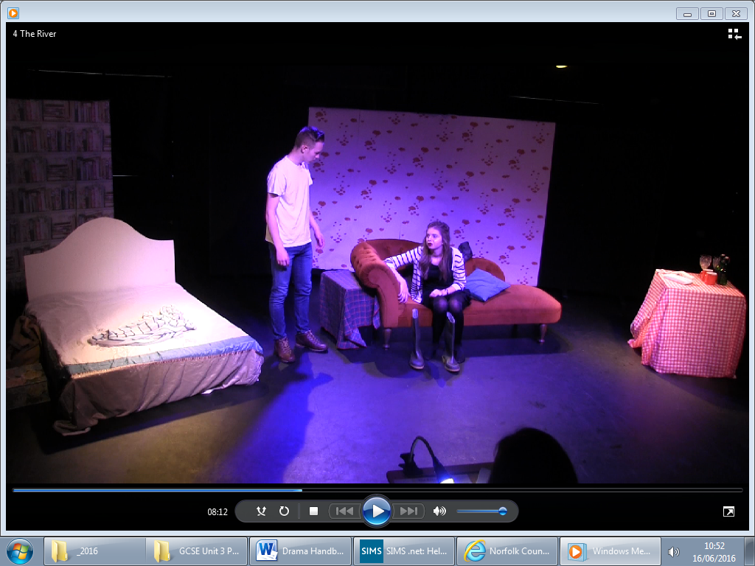
GCSE Drama is an exciting, inspiring and practical course that promotes involvement in and enjoyment of theatre: as actors, directors and designers. Additionally, it provides opportunities to attend live theatre performances and to develop skills as informed and thoughtful audience members.

TIPS FROM GCSE DRAMA STUDENTS
“Come to lessons prepared”

“Learn your lines early”
“Complete your live theatre notes ASAP.”

“Keep up with your notes, catching up later is nearly impossible.”

“Avoid blackouts, they’re boring!”

“Know the physical space you have to perform and practice with it”

“Record your practical work so you can refer back to it”


“Use whatsapp and Facebook to communicate with your group outside of school”

“Find music, costumes, props and set outside of lesson time“

“There is always something to be done, something to improve “

Getting the most out of the course…
- be reliable, enjoy working with others and be a good team player.
- enjoy performing and enthusiastic to develop your acting ability.
- be keen to develop your confidence and interaction skills.
- willing to commit to the extra rehearsals outside of lesson time.
- take risks and challenge yourself! Try new and different things.
“Create a rehearsal schedule and stick to it.”
“Practice with costumes as early as possible”

“Know the ordering of scenes”

How is the course broken down?
OVERVIEW OF THE COURSE
The course is split into 3 components:

 | Component 1: Understanding Drama | Component 2: Devising Drama (practical) | Component 3: Texts in Practice (practical)
What’s involved | This component is a written exam in which students are assessed on their knowledge and understanding of theatre roles and terminology, understanding of a set text and their ability to analyse and evaluate the live theatre work of others. | This is a practical component in which students are assessed on their ability to create and develop ideas to communicate meaning for theatrical performance, apply theatrical skills to realise artistic intentions in live performance and analyse and evaluate their own work. | This component is a practical component in which students are assessed on their ability to apply theatrical skills to realise artistic intentions in live performance.  This is assessed by an external examiner.
What's assessed | - Knowledge and understanding of drama and theatre  - Study of one set play from a choice of six  - Analysis and evaluation of the work of live theatre makers | - Process of creating devised drama  - Performance of devised drama  - Analysis and evaluation of own work | - Performance of two extracts from one play  Free choice of play but it must contrast with the set play chosen for Component 1
How it's assessed | - Written exam: 1 hour and 45 minutes  - Open book  - 80 marks  - 40% of GCSE | - Devising log (60 marks)  - Devised performance (20 marks)  - 80 marks in total  - 40% of GCSE | - Performance of Extract 1 (20 marks) and Extract 2 (20 marks)  - 40 marks in total  - 20% of GCSE

Assessment objectives
• AO1: Create and develop ideas to communicate meaning for theatrical
performance.
• AO2: Apply theatrical skills to realise artistic intentions in live performance.
• AO3: Demonstrate knowledge and understanding of how drama and theatre is
developed performed.
• AO4: Analyse and evaluate their own work and the work of others.

What is Component 1?
COMPONENT 1
Understanding drama
This component is a written exam in which you are assessed on your knowledge and understanding of how drama and theatre is developed and performed, including in connection to a set play and on your ability to analyse and evaluate the live theatre work of others.

The 1 hour 45 minute written exam accounts for 40% of the course.

The paper is divided into three compulsory sections:

Section A: Theatre roles and terminology

Section B: Study of set text

Section C: Live theatre production.

Section A: Theatre roles and terminology
In Section A you are required to answer four multiple-choice questions on professional theatre maker roles and/or terminology.

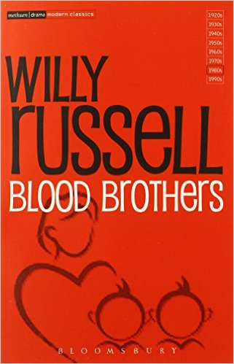
Section A is marked out of 4.

Section B: Study of set text
In Section B you are required to answer short and extended questions on a set play, this is most likely to be Blood Brothers by Willy Russell.

You are expected to know and understand the characteristics and context of the whole play. One extract is printed in the question paper. You must answer questions relating to that extract, referring to the whole play as appropriate to the demands of the question.
Blood Brothers (Methuen Modern Classics – ISBN:
978-0413767707)

Where relevant you may support your answers with sketches or diagrams. You will answer these questions from the perspective of a performer.

The exam will include one compulsory short answer question linking design and context and/or theatrical conventions.

One part of Section B will offer students the choice of answering as either a performer or designer (lighting, sound, set, costume, puppets). You WILL answer as a performer.

Section B is marked out of 44.

** IMPORTANT **
You are allowed to take a CLEAN copy of Blood Brothers into the exam with you. This must NOT contain additional notes, marks, alterations or inclusions.

Section C: Live theatre production

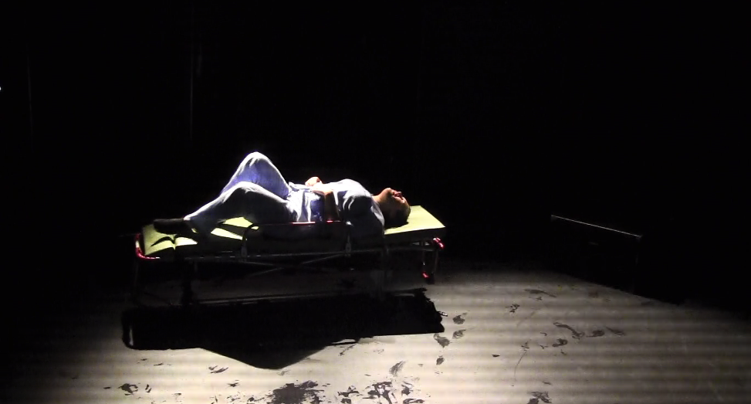
In Section C you answer one question (from a choice) on the work of theatre makers in a single live production. You will have experienced live production as an audience member as part of their course. Trips may include visits to Norwich Theatre Royal, Norwich Playhouse, The Garage, Sewell Barn, Open & further afar theatres including London.

You must discuss a variety of aspects of one production giving a personal analysis and evaluation of the theatrical elements and how successfully meaning was communicated to the audience.

Students are assessed on their knowledge and understanding of the drama and theatre as well as your analytical and evaluative skills.

Section C is marked out of 32.

You cannot not answer Section B and Section C of the exam on the same play
i.e. you cannot write about Blood Brothers in Section C

Conceptual Design Elements (Lighting and Sound):
Act: Scene Title: Pages:
Set Diagram (Draw and label):

Character List: (Who is in this scene?)

Act: Scene Title: Pages:

Aims and Objectives for audience response: (how should they feel, how should they react? What should they think about the characters?

Costume outline for this section/Specific vocabulary: (Colour, items, fabrics, how worn, old or new, patterns, the time period)

Key themes in the scene and how they are explored:

Key lines that are important:

How are you performing the role? Use the information above to write these paragraphs.
- Explain what you want to show in the role of_________________________________in this scene:

- Explain HOW you are performing the role as an actor (Pick a line or two and explain how you would say them. Make sure you mention vocal skills, movement skills and how you are using the space):

- Explain why you are doing this and how it achieves your intentions:

- Explain how the audience would react to this, and what they would learn to help them understand the wider themes of the play:
Act: Scene Title: Pages:

Design
Lighting: Space/ Intensity/ Colour/ Timing and pace/ Atmosphere/ Conventions/ Focus/ Lanterns/ Gels/ Filters/ Special effects/ Gobo
Costume: Colour/ Texture/ Period/ Symbolism/ Character/ Environment/ Social status/ Durability/ Genre/ Movement/ Setting/ Accessories
Sound: Volume/ Pitch/ Music/ Pace/ Period/ Environment/ Mood or Atmosphere/ Special effects/ Fade
Set: Back wall/ Cyclorama/ Trucks/ Flats/ Screens/ Projections/ Dressing/ Furniture
- Performance conventions (strategies)
- Use of space and spatial relationships on stage
- Actor and audience configurations (posh word for where they stand on stage!)
- Relationships between performers and audience
- Performers vocal interpretation of character such as accent/ pitch/ pace/ tone/ volume/ diction/ dialect/ pause/ silence/ phrasing/ emotional range/ delivery of lines
- Performers physical interpretation of character such as build/ age/ height/ facial expressions/ line of sight/ movement/ posture/ gait/ gestures
- Moments of tension/ humour/ suspense/ climax
Other good words:
Convincing
Memorable
Believable
Delivery
Interaction
Demonstrates
Tension
Impact
HELP! I don’t know what to write about…
Evaluation points you might like to include:
Entertaining because… Insight in to the characters….
Realistic because… Creates mood/ atmosphere/Tension…
Imaginative because… Makes the audience feel…
Visually interesting because… Improved the pace…
Adds information for the audience… Makes the audience feel…
Gives the emotional impact of… Helps the audience understand that…
Makes something clear to the audience…


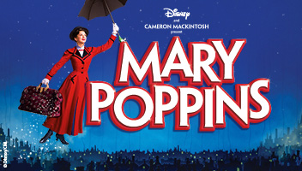



COMPONENT 2
DEVISING DRAMA

What is Component 2?
This is a practical component in which you are assessed on your ability to create and develop ideas to communicate meaning for theatrical performance, apply theatrical skills to realise artistic intentions in live performance and analyse and evaluate your own work.

Devising drama is worth 40% of the GCSE.

It is marked out of 80 by Mr Rayner & Miss Stanley and moderated by AQA.

You are required to complete the following two assessment tasks:

- produce an individual Devising log documenting the devising process (marked out of 60)

- contribute to a final devised duologue or group performance (marked out of 20)
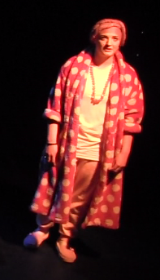
The Devising Log
You required to complete a Devising log documenting the creation and development of your ideas to communicate meaning through a devised piece and analysing and evaluating your individual contribution to the devising process and the final devised piece.

The Devising log must comprise three sections, each marked out of 20 marks:

- Section 1: Response to a stimulus

- Section 2: Development and collaboration

- Section 3: Analysis and evaluation.
Section 1: Response to a stimulus

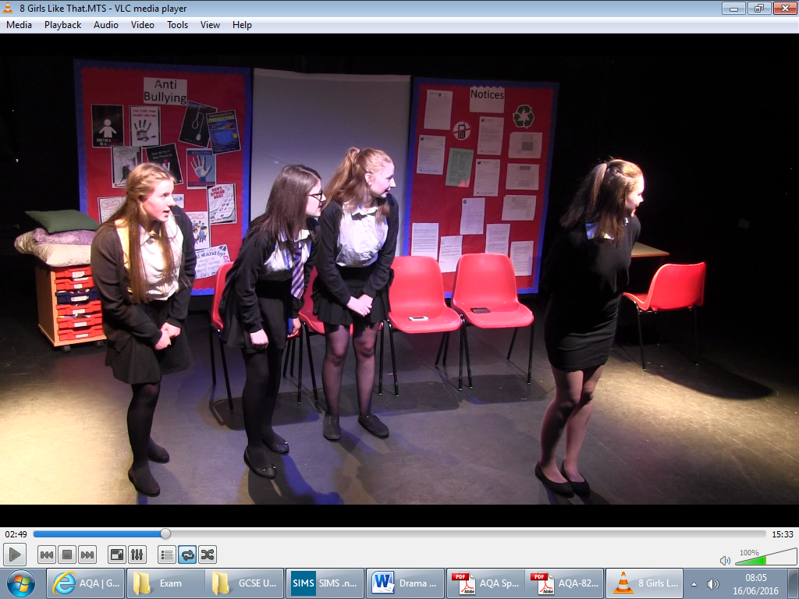
In this section you are expected to explain your initial ideas, research and intentions for the devised piece.

You must explain:

- your initial response to the stimuli and the stimulus you chose

- the ideas, themes and settings you have considered for the devised piece in response to the stimulus you chose

- your research findings

- your own dramatic aims and intentions

- the dramatic aims and intentions of the piece as a whole.

Section 2: Development and collaboration

In this section you are expected to explain the process you undertook to refine your initial ideas and intentions into a final devised piece.

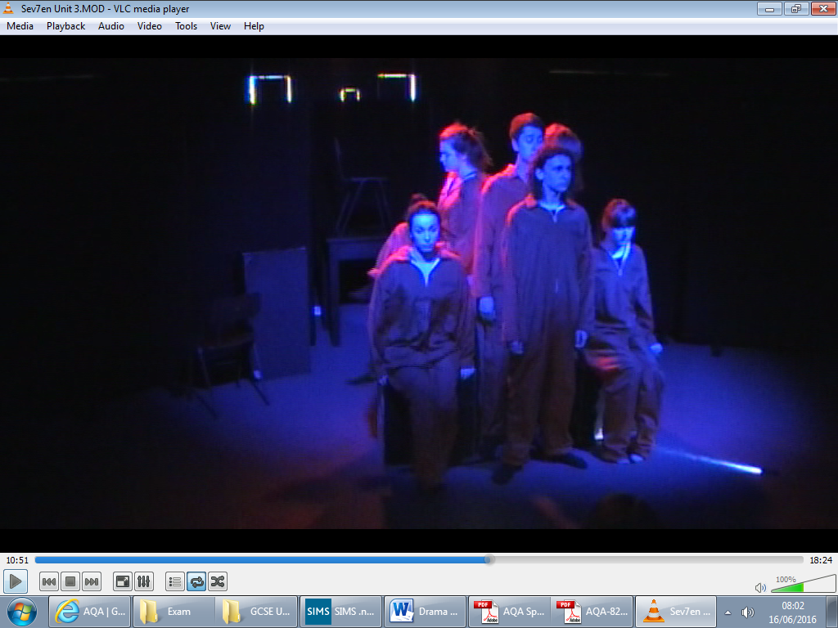
You must explain:

- how you developed and refined your own ideas and those of the pair/group

- how you developed and refined the piece in rehearsal

- how you developed and refined your own theatrical skills during the devising process

- how you responded to feedback

- how you as individuals used your refined theatrical skills and ideas in the final piece.

Section 3: Analysis and evaluation

In this section you are required demonstrate your analytical and evaluative skills with respect to your own devised work.

You are expected to analyse and evaluate the ways in which you individually contributed to the devising process as a whole and to the final devised piece, exploring your strengths and the learning opportunities taken from the experience.

You should analyse and evaluate:

- how far you have developed your theatrical skills

- the benefits you brought to the pair/group and the way in which they positively shaped the outcome

- the overall impact you have had.

You should also identify areas for further development in your future devising work (i.e. the aspects that did not go as well as you had hoped).

to analyse’ is to identify
and investigate…

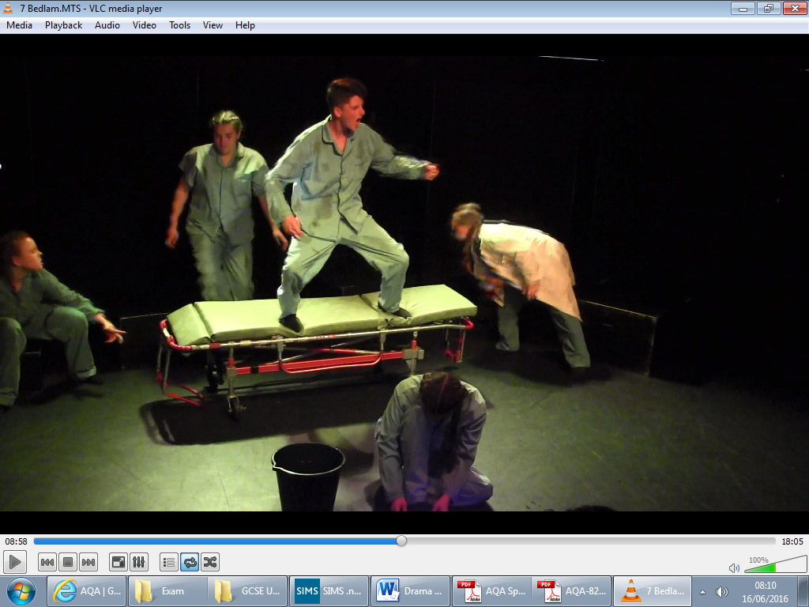

… to ‘evaluate’ is to assess the merit of the different approaches used and formulate judgements

The Devised Performance

You are required to contribute to a devised duologue or devised group piece. The assessed performance for this component cannot be a monologue.
Type | Performance duration
Duologue (two performers) | Must be between three and ten minutes.
Group performance (three or more | Must be between four and twenty minutes.
performers)

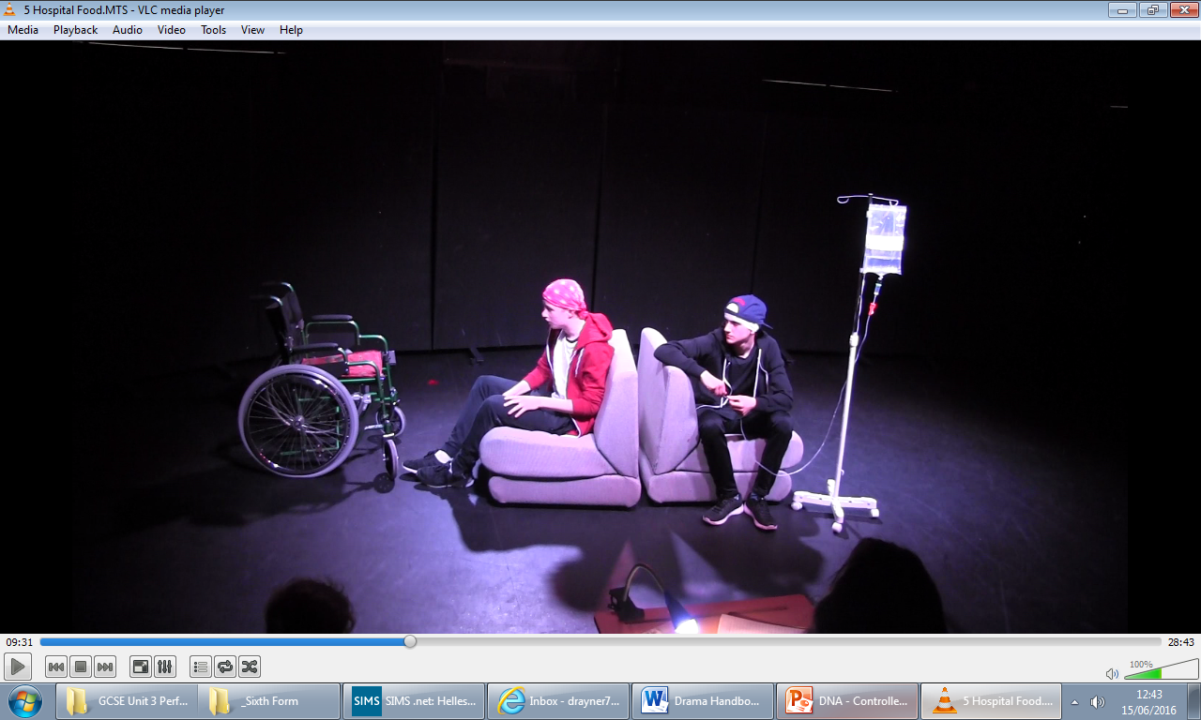
For group performances playing time for each performance should reflect the number of performance students in the group e.g. a group with six performance candidates should work to the upper time limit.

Performances which fail to meet these minimum performance times will be subject to a mark of zero.

You are assessed on the following:
- the level of theatrical skills demonstrated in your performance or design
- the range of theatrical skills demonstrated in your performance or design
- your contribution to the effectiveness of the piece, made through your performance or design
- the inventiveness of your work, as evidenced through your performance or design
- your success in realising your individual artistic intentions, as evidenced by your performance or design when considered against your Statement of Dramatic Intentions
“The Statement of Dramatic Intentions must be completed by the student on the template AQA provides. This statement is not assessed directly but should be used to support assessment. Assessment must not take place without reference to the student’s Statement of Dramatic Intentions.” See below for an example…
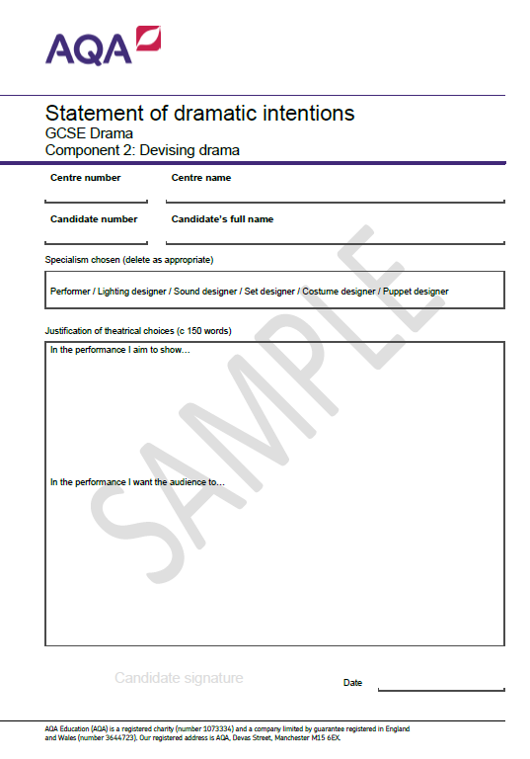

Hellesdon High School
18107

Component 2: Assessment Criteria
The assessment objective being assessed is AO1: Create and develop ideas to communicate meaning for theatrical performance.

Devising Log Section 1 (20 marks)
Band | Mark | Descriptors
4 | 16 - 20 | Excellent response:  - The explanations given in the Devising log evidence excellent skills in creating and developing ideas to communicate meaning.  - There is evidence of a highly developed and highly creative response to the stimulus.  - The explanation is very clear and points are comprehensively explored.  - Precise details are provided throughout.
3 | 11 - 15 | Good response:  - The explanations given in the Devising log evidence good skills in creating and developing ideas to communicate meaning.  - There is evidence of a creative and engaged response to the stimulus.  - The explanation is clear and most points are explored in some detail.  - A number of precise details are provided.
2 | 6 – 10 | Reasonable response:  - The explanations given in the Devising log evidence reasonable skills in creating and developing ideas to communicate meaning.  - There is evidence of a meaningful response to the stimulus which shows some creativity.  - The explanation is reasonably clear but some points are not explored.  - A few precise details are provided.
1 | 1 - 5 | Limited response:  - The explanations given in the Devising log evidence limited skills in creating and developing ideas to communicate meaning.  - There is evidence of an under-developed response to the stimulus.  - The explanation lacks clarity and depth.  - Minimal detail is provided.
0 | 0 | Nothing worthy of credit.
The assessment objective being assessed is AO1: Create and develop ideas to communicate meaning for theatrical performance.

Devising Log Section 2 (20 marks)
Band | Mark | Descriptors
4 | 16 - 20 | Excellent response:  - The explanations given in the Devising log evidence excellent skills in creating and developing ideas to communicate meaning.  - There is evidence of extensive and highly effective development and refinement of skills and the piece.  - The explanation is very clear and points are comprehensively explored.  - Precise details are provided throughout.
3 | 11 - 15 | Good response:  - The explanations given in the Devising log evidence good skills in creating and developing ideas to communicate meaning.  - There is evidence of considerable and mostly effective development and refinement of skills and the piece.  - The explanation is clear and most points are explored in some detail.  - A number of precise details are provided.
2 | 6 – 10 | Reasonable response:  - The explanations given in the Devising log evidence reasonable skills in creating and developing ideas to communicate meaning.  - There is evidence of some meaningful development and refinement of skills and the piece.  - The explanation is reasonably clear but some points are not explored.  - A few precise details are provided.
1 | 1 - 5 | Limited response:  - The explanations given in the Devising log evidence limited skills in creating and developing ideas to communicate meaning.  - There is evidence of little development and refinement of skills and the piece.  - The explanation lacks clarity and depth.  - Minimal detail is provided.
0 | 0 | Nothing worthy of credit.

The assessment objective being assessed is AO4: Analyse and evaluate their own work and the work of others.
Devising Log Section 3 (20 marks)
Band | Mark | Descriptors
4 | 16 - 20 | Excellent analysis and evaluation:  - Response demonstrates highly developed skills in identifying and investigating how far they developed their theatrical skills and how successfully they contributed to the devising process and to the final devised piece (analysis).  - Response demonstrates highly developed skills in assessing the merit of different approaches and formulating judgements about the overall impact they had as an individual (evaluation).  - Response is critical and insightful.  - Points are comprehensively explored and supported in depth with thorough exemplification.
3 | 11 - 15 | Good analysis and evaluation:  - Response demonstrates developed and secure skills in identifying and investigating how far they developed their theatrical skills and how successfully they contributed to the devising process and to the final devised piece (analysis).  - Response demonstrates developed and secure skills in assessing the merit of different approaches and formulating judgements about the overall impact they had as an individual (evaluation).  - Response is developed and clear.  - Points are explored and supported with a number of examples.
2 | 6 – 10 | Reasonable analysis and evaluation:  - Response demonstrates some developing skill in identifying and investigating how far they developed their theatrical skills and how successfully they contributed to the devising process and to the final devised piece (analysis).  - Response demonstrates some developing skill in assessing the merit of different approaches and formulating judgements about the overall impact they had as an individual (evaluation).  - Response is reasonably clear but at points relies on description.  - Points made are sound but may not be explored or supported.
1 | 1 - 5 | Limited analysis and evaluation:  - Response demonstrates undeveloped skills in identifying and investigating how far they developed their theatrical skills and how successfully they contributed to the devising process and to the final devised piece (analysis).  - Response demonstrates undeveloped skills in assessing the merit of different approaches and formulating judgements about the overall impact they had as an individual (evaluation).  - Response is mostly descriptive and lacks examples.
You required to complete a Devising log documenting the creation and development of your ideas to communicate meaning through a devised piece and analysing and evaluating your individual contribution to the devising process and the final devised piece.
Writing the Devising Log

The Devising log must comprise three sections, each marked out of 20 marks:

- Section 1: Response to a stimulus (20marks)

- Section 2: Development and collaboration (20marks)

- Section 3: Analysis and evaluation (20marks)

Section 1: Response to a stimulus
In this section you are expected to explain your initial ideas, research and intentions for the devised piece. Provide as much specific detail as possible, make sure that you detail developed and highly creative response to the stimuli. You must also demonstrate excellent skill in the creation and development of ideas to communicate meaning.
Use the following subheadings to structure your work:
Your initial response to the stimuli: What was presented by the teacher and which of the stimuli have you chosen? What did you notice initially? (Colours, shapes, mood, feeling, themes, ideas etc.) How did this first impression change? How did it make you feel?
Ideas, themes and settings: What have you considered for the devised piece in response to the stimulus your group has chosen?
Research: Your research findings and how this is shaping your ideas for creating theatre
Dramatic aims and intentions: ​​Both as a performer and an individual and a bullet point list of the groups aims overall.

Section 2: Development and collaboration

In this section you must give detailed explanations of how you are creating practical work and developing ideas to communicate meaning. Use the subheading below. You must give examples of HOW you are developing your skills as an actor for example:

“We decided that I would multi-role the part of Evan’s mother and his friend at school. Initially I showed this with a costume change but as I grew more confident I experimented in changing my voice. I started to use a louder volume and self-assure tone as Evan’s friend, using sarcasm to show my youth and playfulness. I was also more physical on stage in this role, using a wide stance and energetic gestures. When performing mother I contrasted this by making my movements slower and more pained, I also spoke with a softer tone. I think this will be effective in achieving my aim of convening two different characters but also in generating empathy for what Evan’s mother has gone through.”

Development of Ideas: How you developed and refined your own ideas and those of the pair/group. Focus on your research and the aims you would like to achieve for the audiences experience of the performance.

Development of the Piece: How you developed and refined the piece in rehearsal. Focus on the devising process and how ideas changed and evolved based on research and practical exploration. Give specific details.

Development of Personal Skills: How you developed and refined your own theatrical skills during the devising process. (See example above)

Response to Feedback: How did you respond to the feedback given? What feedback you got, what you changed and why?

Overall aims for the audience: This can be the same for each person in the group but you should list your performance aims. Explanation of how you will go about achieving them needs to be individual.

Section 3: Analysis and evaluation

In this section you are required to analyse and evaluate the ways in which you individually contributed to the devising process as a whole and to the final devised piece, exploring your strengths and the learning opportunities taken from the experience.

You should analyse and evaluate:

Evaluation of my Practical Acting Skill: How far you have developed your theatrical skills? How successful were you in contributing ideas in the devising process? How good was your final performance? What skills did you demonstrate? Did your personal acting achieve your aims?

Examples of Development: Explain the benefits you brought to the pair/group and the way in which they positively shaped the outcome. Did you complete research? If so what and how did it shape the final piece? What ideas did you contribute to the devising process? Why were they effective? Did you demonstrate practical skills? If so what where they and why were they successful? Explain the overall impact you have had on the piece. Did your piece fulfil the overall group aims for it?

Examples of Future development: You should also identify areas for further development in your future devising work (i.e. the aspects that did not go as well as you had hoped). If you didn’t achieve your aims how would you do this next time? Would you do anything differently if you were to perform it again? If so what? Link this to the aims of your piece.

Mark | Level of theatrical  skill | Range of theatrical  skills demonstrated | Contribution to the  effectiveness of  the piece | Inventiveness  of individual's work | Success in realising  individual artistic  intention
4 | Highly competent,  highly developed  and sustained use of theatrical skill. | Extensive range of  theatrical skills  demonstrated. | Outstanding  contribution to the  effectiveness of the  piece. | Highly inventive work throughout. | Highly successful  realisation of  individual artistic  intention.
3 | Developed,  secure and consistent use of  theatrical skill. | Wide range of  theatrical skills  demonstrated. | Considerable  contribution to the  effectiveness of the  piece. | Work has many  inventive qualities or  moments. | Secure success in realising individual  artistic intention.
2 | Some developing  competency in use of  theatrical skill, not always sustained. | Fair range of  theatrical skills  demonstrated. | Some meaningful  contributions to the  effectiveness of the  piece. | Some useful  inventive ideas. | Some success in  realising individual  artistic intention.
1 | Little competency  and little  consistency in use of  theatrical skill. | Narrow range of theatrical skills demonstrated. | Little contribution to the effectiveness of  the piece. | Little inventiveness. | Little success in realising individual  artistic intention.
0 | Nothing worthy of credit. | Nothing worthy of credit. | Nothing worthy of credit. | Nothing worthy  of credit. | Nothing worthy of  credit.

There are 20 marks available. You are awarded either 1 mark, 2 marks, 3 marks, or 4 marks for each of the five criteria.
The assessment objective being assessed is AO2: Apply theatrical skills to realise artistic intentions in live performance.

What is Component 3?
COMPONENT 3
Texts in practice
This component is a practical component in which students are assessed on their ability to apply theatrical skills to realise artistic intentions in live performance (AO2).

Texts in practice is worth 20% of the GCSE.

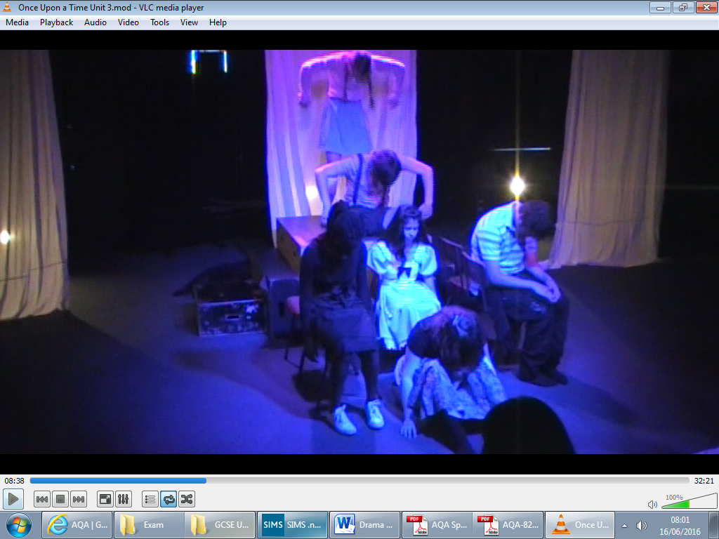
For this component you must complete two assessment tasks:

- study and present a key extract (monologue, duologue or group performance)

- study and present a second key extract (monologue, duologue or group performance) from the same play.

Each extract is worth 20 marks, 40 in total, and is marked by external AQA examiner.

Extract 1 may be a monologue, duologue or a group piece.

Extract 2 may be a monologue, duologue or a group piece.

Type | Performance duration
Monologue (one performer) | Must be between two and five minutes.
Duologue (two performers) | Must be between three and ten minutes.
Group performance (three or more | Must be between four and twenty minutes.
performers)

Performances which fail to meet these minimum performance times will be subject to a mark of zero.
“It must be very clear to the AQA assessor when the performance of Extract 1 is over and the performance of Extract 2 has begun. This is because each student will be awarded two marks for Component 3: one for Extract 1 and one for Extract 2. The distinction between Extract 1 and Extract 2 may be achieved in a variety of different ways and, as long as the distinction is clear to the AQA assessor, any method is acceptable.”

The Assessment Criteria:
The assessment objective being assessed is AO2: Apply theatrical skills to realise artistic intentions in live performance.

Component 3: Texts in Practice
Band | Mark | Descriptors
4 | 16 - 20 | Excellent contribution to performance:  • An extensive range of skills are demonstrated.  • Skills are deployed precisely and in a highly effective way.  • Personal interpretation is entirely appropriate to the play as a whole.  • Personal interpretation is highly sensitive to context.  • Artistic intentions are entirely achieved.
3 | 11 - 15 | Good contribution to performance:  • Wide range of skills are demonstrated.  • Skills are deployed confidently and in a mostly effective way.  • Personal interpretation exhibits a good degree of appropriateness to  the play as a whole.  • Personal interpretation exhibits a good degree of sensitivity to context.  • Artistic intentions are mostly achieved.
2 | 6 – 10 | Reasonable contribution to performance:  • Fair range of skills are demonstrated.  • Skills are deployed with care and with effectiveness in places.  • Personal interpretation has some relevance to the play as a whole.  • Personal interpretation is sensitive to context in places.  • Artistic intentions are partly achieved.
1 | 1 - 5 | Limited contribution to performance:  • Narrow range of skills are demonstrated.  • Skills are deployed uncertainly with little effectiveness.  • Personal interpretation lacks appropriateness for the play as a  whole.  • Personal interpretation lacks sensitivity to context.  • Artistic intentions are achieved to a minimal extent.
0 | 0 | Nothing worthy of credit.

Live Theatre
On the day of the performance
You will want to write notes to ensure you remember details of the production. However, you should avoid trying to write extensive notes as this may be distracting for other members of the audience. You can write notes during the interval and after the performance has ended.
Here is an example extract from one student’s notes:
Acting:
Main character very quick movements…and loud, aggressive voice effectively showing the tension and his anger at this point in the play
Scene two – use of space effective with girlfriend when they argue…they stood very close together which effectively communicated their feeling of claustrophobia
Design:
Lighting very dark and threatening during the storm. Use of special FX – thunder. Created suspense and atmosphere of fore boarding when characters came on stage

After the performance
- Expand your notes on the different things you have observed in the performance and what affects these had on you. Add any further details and fill in any gaps
- Check factual information: get the names of characters and plot details right (especially if you have not seen or read the play before). Use the programme!
- Make sure you remember the effect the production had on the audience and you while it is still fresh.
- Use the live theatre framework to help you!
“The stage is a magic circle where only the most real things happen, a neutral territory outside the jurisdiction of Fate where stars may be crossed with impunity. A truer and more real place does not exist in all the universe.”
P.S. Baber, Cassie Draws the Universe
“What is that unforgettable line?”
Samuel Beckett

Actors need a kind of aggression, a kind of inner force.
Don't be only one-sided, sweet, nice, good. Get rid of
being average. Find the killer in you.”
Stella Adler, The Art of Acting

Live Theatre: Instructions
This information is designed to help you complete Component 1: Live Theatre in which you need to critically review a live theatre production. THIS MUST BE DETAILED!
.
YOU MUST HAVE REFERRED TO ATLEAST 5 MOMENTS FROM THE PRODUCTION.
A ‘MOMENT’ CAN BE AS BRIEF AS AN CTOR GIVING AN OBJECT TO ANOTHER/ A MOMENTARY USE OF PROJECTION ETC.
YOU MUST ANALYSE HOW THE FOLLOWING WAS USED TO COMMUNICATE THE AIMS, STYLE OR AFFECTS OF THE PRODUCTION IN EACH MOMENT YOU DICUSS.
- The actors’ use of physical qualities **
(Facial expression, posture, gesture, mannerism, movement, pace, spatial relations, stillness, levels, contrast, status, mood and atmosphere, relationship to aim, effect, style and genre)
- The actors’ use of vocal qualities **
(Volume, pitch, pace, tone, accent, projection, clarity, diction, dialect, intonation, emphasis, timing, song, verse, narration, silence, mood and atmosphere, relationship to aim, effect, style and genre)

- Costume
(Textures, colours, period, symbolism, durability, relationship to aim, effects, style and genre)
- Lighting and Sound
(Colour, symbolism, intensity, gels, gobos, special effects, volume, direction, texture, timing, pace, atmosphere, relationship to aim, effect, style and genre)
- Setting
(Symbolism, multi-location, textual demands, location, period, mood and atmosphere, rostra and levels, imagery, projection, relationship to aim, effect, style and genre)
AS WELL AS ANASLYSISNG THE PRCTICAL SKILLS OF THE PRODUCTION YOU HAVE SEEN YOU ARE EXPECTED TO EVALUATE THE SUCCESS OF THE PRODUCTION.
YOU SHOULD THEREFORE, FOR EVERY MOMENT THAT YOU DICUSS:
- Make a personal evaluation- how effectively do you, as an audience member, feel the aims and effects were achieved?

Live Theatre: Framework
What was the title of the play, the date you saw it and what was the venue?

What was the theatrical style and genre of the performance, and which elements of each were present in the production?

What were the aims and intended effects of the production?
(What did the director or theatre company set out to do?)

What was the chosen staging form? What effect did this have on the actor/ audience relationship? How did this suit the aims of the performance? How did this relate to the production’s style?
(include a diagram of the stage, making sure you indicate the position of the audience)

1st Moment
Moment Checklist:
Have you included…?
- Costume
- Lighting
- Sounds
- Setting
- Period
- Physical Performance
- Vocal Performance
- Reference to the production’s style, aims and effects
- Personal evaluation

2nd Moment

3rd Moment
Moment Checklist:
Have you included…?
- Costume
- Lighting
- Sounds
- Setting
- Period
- Physical Performance
- Vocal Performance
- Reference to the production’s style, aims and effects
- Personal evaluation
- evaluation

4th Moment

5th Moment
Moment Checklist:
Have you included…?
- Costume
- Lighting
- Sounds
- Setting
- Period
- Physical Performance
- Vocal Performance
- Reference to the production’s style, aims and effects
- Personal evaluation
- evaluation

6th Moment



Writing
Descriptive vs. Reflective writing
Descriptive | Reflective
We started by… | Initially I thought…
The first thing I did was…/ our first task was… | Whilst working through the first task…
When we watched… | On observing…I felt/thought/saw/heard…
Then we… | Developing on from…
Then we got into groups… | Working in groups of four I felt…
After we did… | On completion of…I felt…
Next we… | At some point…
In our next session… | The scream task, to me, was by far the most challenging because…
Mr Rayner told us…/ Miss Stanley said… | To begin with, I thought that “madness” was…

Sentence starters
To communicate/symbolise/tell the story of…
I felt that…
I believe that…
I think that…
In hindsight…
This was effective because…
We used this because…
We did this because…
By acting…I communicated the idea of…
When sharing work…
When viewing other groups work/pieces…
As a member of the audience…
This moment stood out for me because…
Their use of… was effective because…
…was used effectively by…/because we…
Key moments were…because…
I saw improvement/progress made by…because…
The feedback we received/that was given helped me/… improve by/because…
They demonstrated…
The audience’s reaction…
When they…it was effective because…
I like how they used…
I thought…could improve their (use of)…because/by…
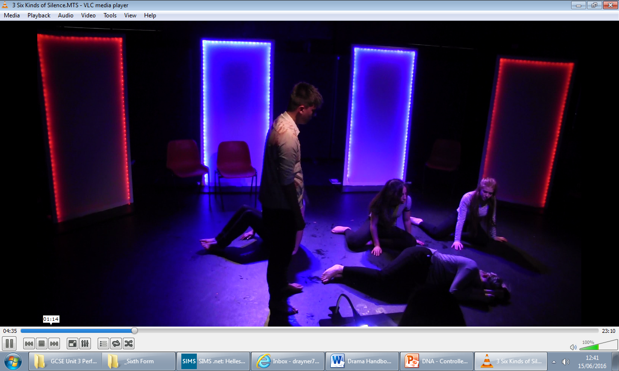
…worked collaboratively within our/their group…

Key Vocabulary
Accent – the way a person speaks that tells you where they are from, e.g. Geordie, Cockney, Scottish, etc.
Aesthetic –the way something looks, usually something that looks good
Antagonist – the opponent or adversary of the hero or main character of a drama.
Approach – the method used or steps taken in setting about a task/problem
Articulate – to speak clearly so every letter/word can be heard
Collaboration – when artists work together; a performance is an artistic collaboration because it relies on the work of a team of people.
Comic relief – a break in the tension of a tragedy provided by a comic character, a comic episode, or even a comic line
Compose – to make up; to organise the parts or elements
Conflict – the internal or external struggle between opposing forces, ideas, or interests that creates dramatic tension.
Contrast – dynamic use of opposites, such as movement/stillness, sound/silence, and light/darkness.
Cross-gender casting – girls play boys and vice versa
Cue – a signal that prompts action from an actor or technician
Dialogue – the spoken language in a performance between two or more people
Diction – selection and pronunciation of words; clarity of speech.
Dramatic irony – the audience know something important but the characters in the performance are not aware of it
Empathy – understanding someone’s feelings
Enact – to represent or perform in or as if in a play; to act out
Evaluation – discussing how effective/successful or significant something was
Focus – in lighting, the size and shape of a stage light and/or the direction in which it is aimed; in acting, the act of concentrating or staying in character.
Genre – identifiable characteristics, e.g. comedy, tragedy, thriller
Heighten – to increase/strengthen
Identify – to recognise or establish the identity of something; to make/represent something to be the same or identical as something
Imitate – to copy or mimic the actions, appearance, mannerisms, or speech of others.
Improvisation – the spontaneous use of movement and speech to create a character or object in a particular situation; acting done without a script
Indicate – to be a sign of; to point out/to; to show
Inflection – raising or lowering the tone or pitch of the voice, e.g. downwards inflection at the ends of sentences
Irony – an implied discrepancy between what is said and what is meant
Interaction – the action or relationship among two or more characters.
Interpretation – an explanation of the meaning of another’s artistic or creative work; to bring out the meaning, or one’s understanding of it
Justify – to show to be right; to defend or uphold as well-grounded; to show a satisfactory reason
Mannerism – a peculiarity of speech or behaviour
Melodrama – a style of play, which originated in the 19th century, relying heavily on sensationalism and sentimentality. Melodramas tend to feature action more than motivation, stock characters, and a strict view of morality in which good triumphs over evil.
Mime – acting without words.
Mimicry – the practice of mimicking or imitating.
Mirroring – copying the movement and/or expression or look of someone else exactly.
Monologue – a lengthy speech performed by an actor, revealing feelings or commenting on events
Montage –used in TV and films and by Brecht; the putting together of short sections or scenes that are dissimilar
Mood – the tone or feeling of the play, often engendered by the music, setting, or lighting.
Motivation – the reason or reasons for a character’s behaviour; an incentive or inducement for further action for a character.
Naturalistic – shows characters behaving in natural ways (how you would expect)
Pace – is the speed at which you speak
Pantomime – acting without words.
Parody – a mocking or satirical imitation of a literary or dramatic work.
Pause – refers to short breaks and stops in your speech to create effects
Personification – the attribution of human qualities to inanimate objects or abstract concepts.
Perspective – a way of regarding situations, facts, etc., and judging their importance
Physical theatre – using the body to represent inanimate objects, e.g. kettle, toaster etc.
Pitch – is the high or low level of the voice
Protagonist – the main character or hero in a play or other literary work.
Proxemics – showing the relationship between people through the physical distance
Rapport – the relationship of a group; how well they communicate and work together
Realistic –show life as it really is
Reflect – to think, ponder, meditate
Satire – a play in which sarcasm, irony, and ridicule are used to expose or attack folly or pretension in society.
Scenario – an outline of a hypothesized or projected chain of events or plot for a dramatic or literary work.
Scene – a small section or portion of a play.
Set – the physical surroundings, visible to the audience, in which the action of the play takes place.
Setting – when and where the action of a play takes place.
Situation – a combination of circumstances at a given moment.
Soliloquy –when an actor speaks directly to an audience as if revealing thoughts; usually alone on stage/isolated from other characters
Spectator – a person who is watching; member of an audience
Spotlight –light focused on a single place on the stage
Stereotyping – a shallow idea about a person or place, e.g. boys liking football and girls liking shopping
Stimulus/stimuli – something you gain ideas from
Stylised –does not attempt to look ‘real’
Symbolic – something represents something else, e.g. white =innocence, purity
Themes – a generalised topic, e.g. heroes, body image, domestic abuse
Tone – is the quality of the sound of your voice.

Adjective Bank

Vocal Qualities: Tone/ Pitch/ Pace/ Volume/ Mannerism/ Accent
Harsh Cold Assertive Cheeky
Gentle Angry Loud Controlled
Sarcastic Persuasive Deep Husky
Abrupt Authoritative High Pitched Anxious
Stilted Soft Submissive Seductive
Forceful Proud Sly Enthusiastic
Derogatory Meek Abrasive Timid
Firm Hesitant Quivery Assured
Trusting Whiney Warm Stutter

Body Language and Movement: Posture/ Gesture/ Mannerism/ Use of Space
Rapid Formal Purposeful Hasty
Slow Closed Measured Nervous
Sluggish Jerky Controlled Sedate
Gentle Smooth Wild Energetic
Sympathetic Strong Dismissive Informal
Twitchy Direct Relaxed Open
Decisive Rushed Aggressive Grotesque
Indecisive Secretive Hesitant Tense

Facial Expression:
Happy Cheerful Upset Distraught
Hurt Eager Anxious Aggressive
Vague Fearful Rejected Snarling
Smug Defiant Distressed Seductive
Thoughtful Sly Devious Envious

Eye Contact:
Direct Accusing Loving Encouraging
Hurt Strong Weak Crestfallen
Commanding Dejected Consistent Steady
Focused Avoiding Maintained (None)

Interaction with Others:
Close Isolated Warm Friendly
Distant Passive Rejecting Relaxed
Tense Tactile Flinch Intrusive
Shy Cold Defensive Aggressive

Director’s effects or effects for the audience:
Tension Awe Surprise Awareness of Society
Danger Amazement Shock Educational message
Intrigue Anticipation Sympathy Empathy

Audience Responses: This is how the audience FEELS
Sympathy Anti-climax Distaste Horror
Anger Amusement Contempt Empathy
Disappointment Admiration Delight Irritation

NOT what you want the audience to see or to either know or understand.

Designer’s effects: The use of staging, form, set, lighting, sound, costume to create such elements as…
Atmosphere or Mood Location Time/ Time Passing
Period Status/ Class Audience Focus



