🐚 Seashells Class – Spring 2

🚓👩‍🚒 People Who Help Us
Anchored in the community; a place to be, a world to explore.
This half term, Seashells Class will be learning about People Who Help Us. We will explore the important roles people play in our local and wider community and discover how they keep us safe, healthy and happy.
Through stories, role play, visits and practical activities, children will develop their understanding of different jobs and the equipment used to do them.

📚 Core Texts
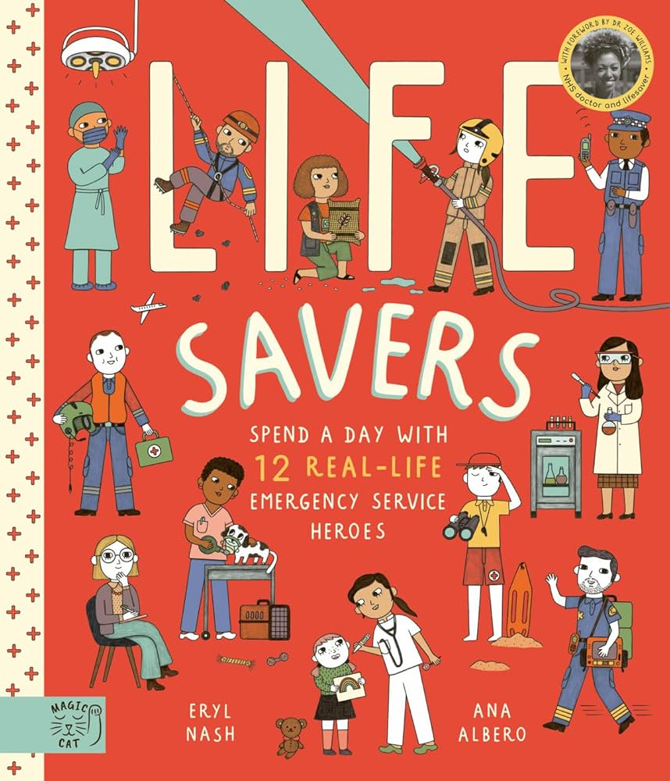
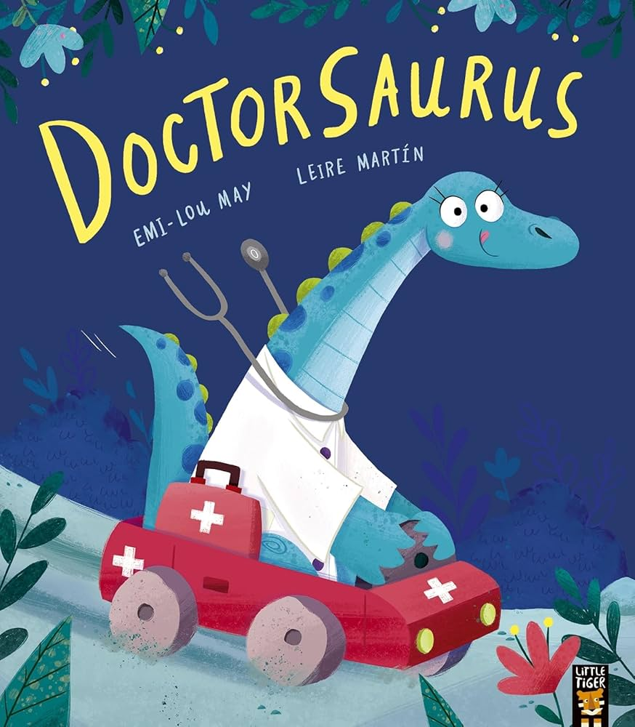
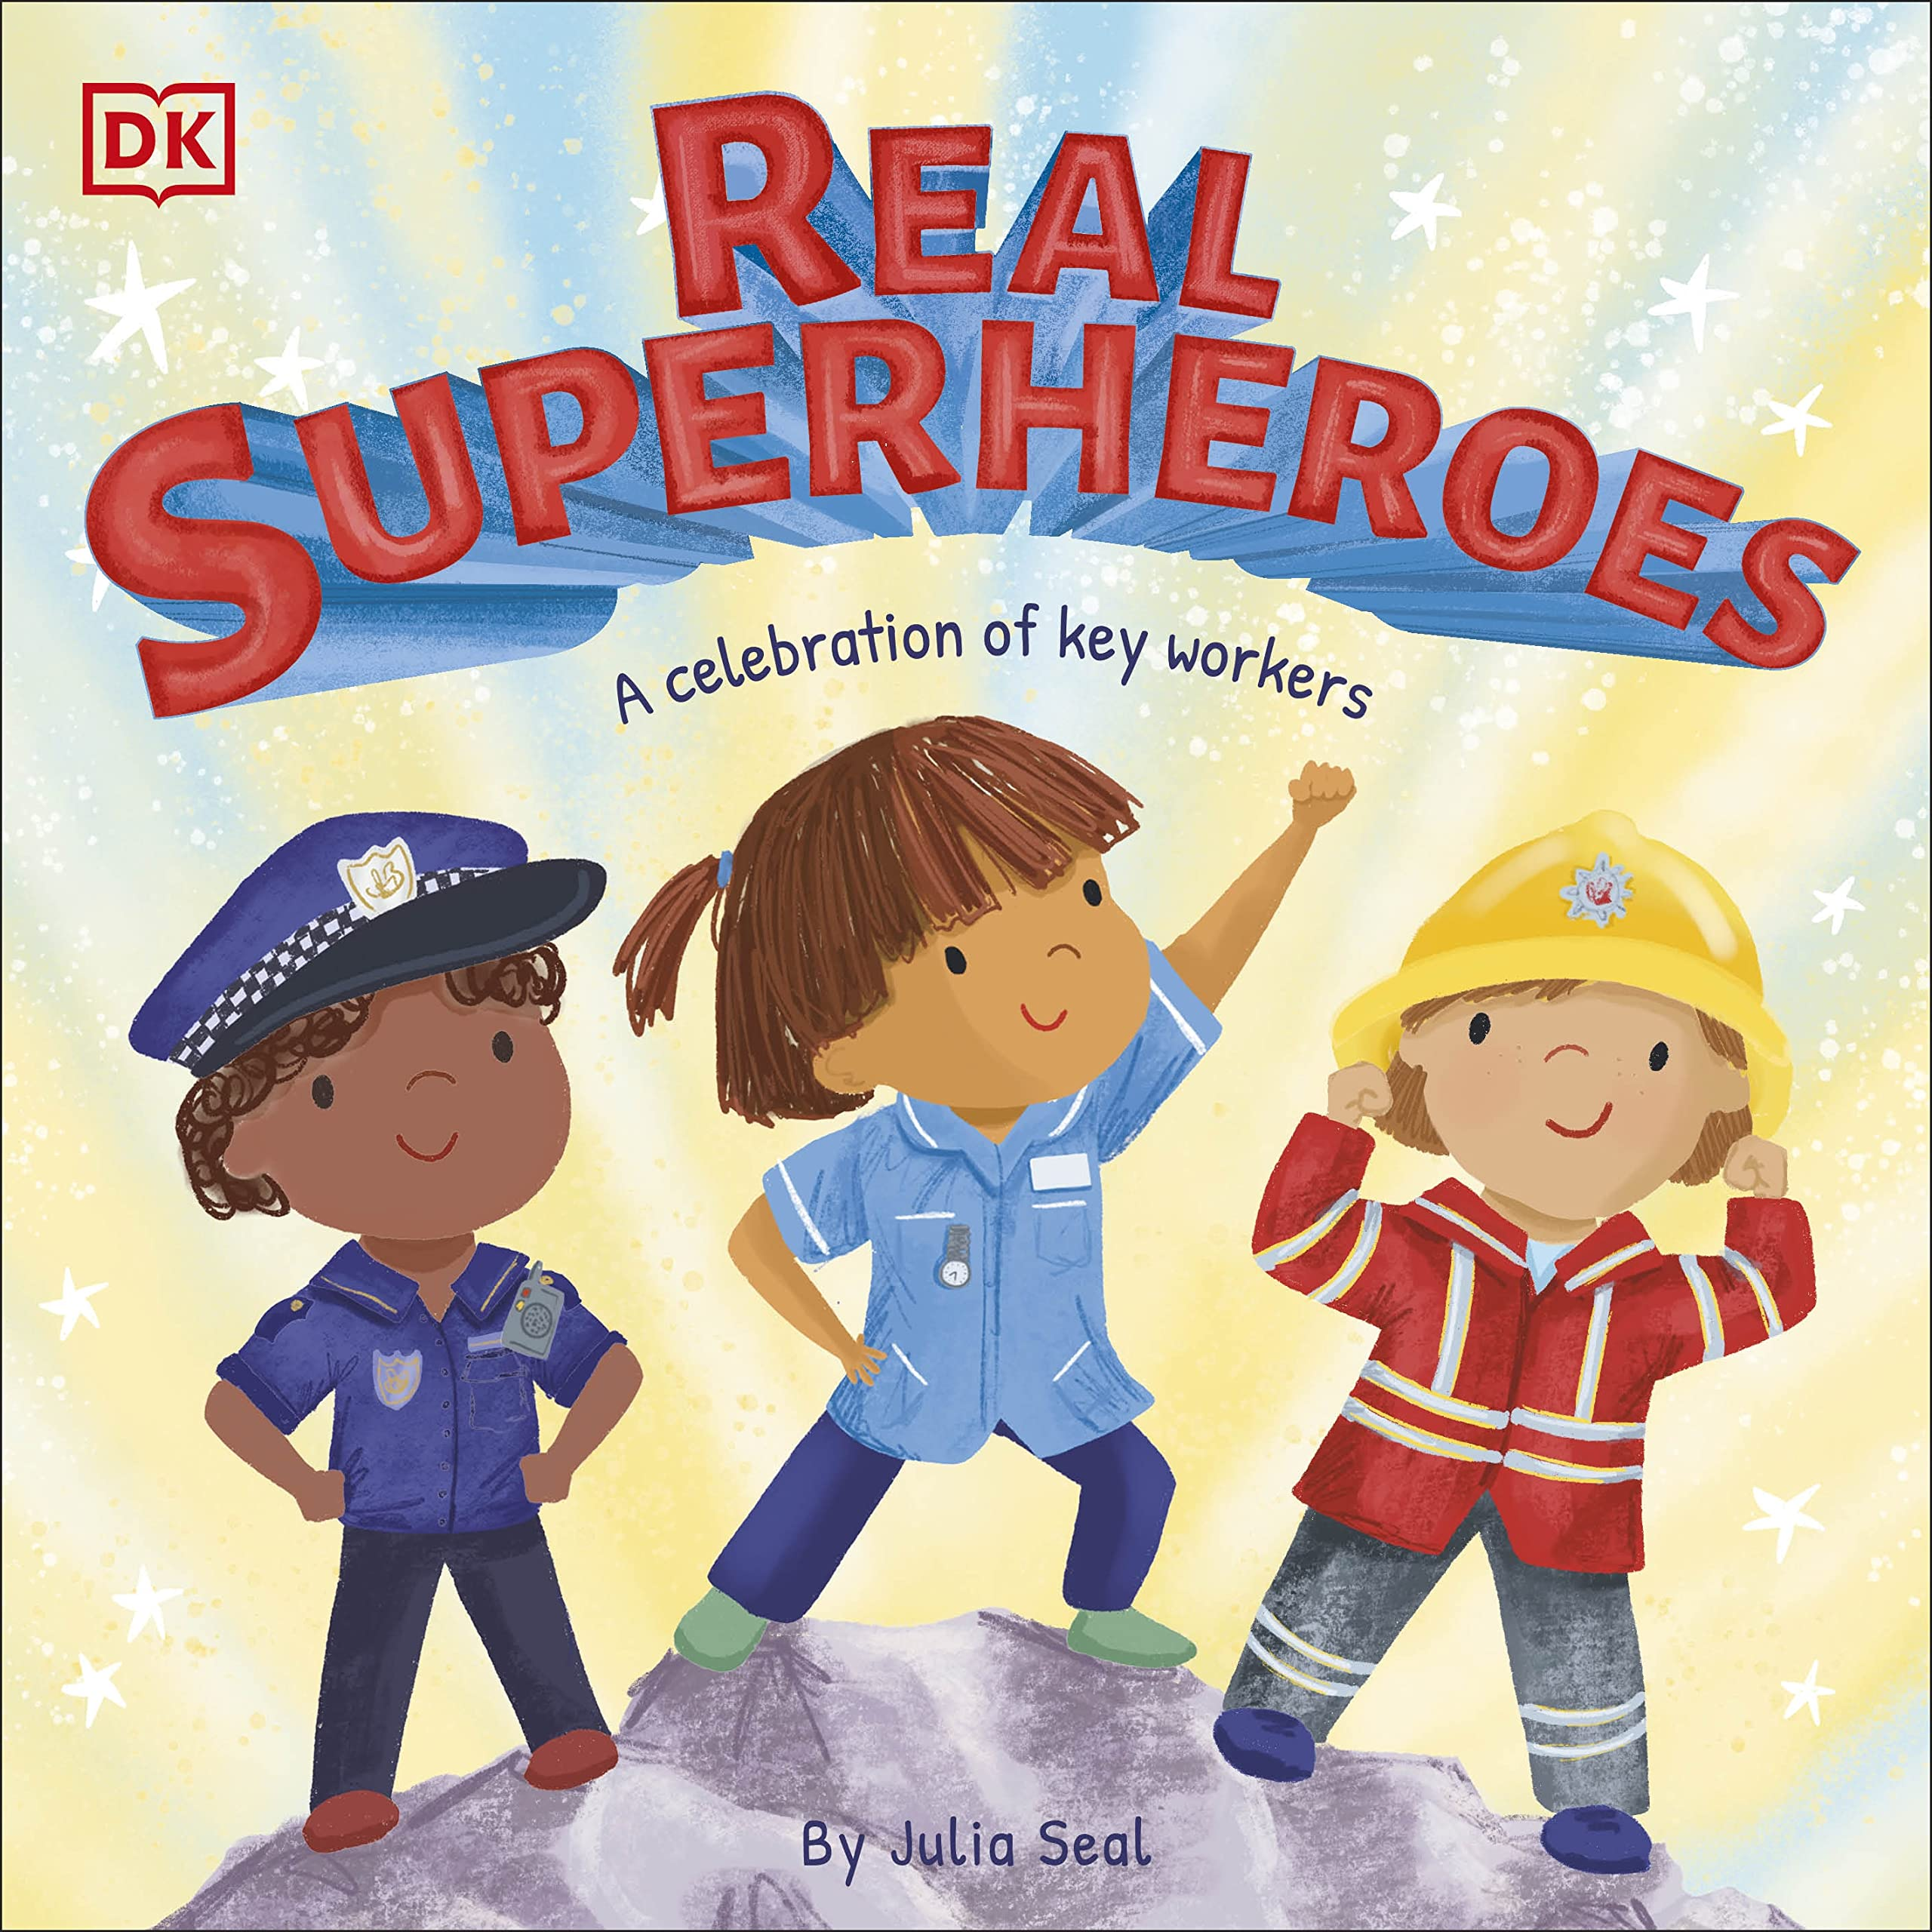
5
We will share a range of exciting books including:
- Lifesavers
- Doctorsaurus
- Real Superheroes
- The Jolly Postman
- You Can’t Call an Elephant in an Emergency
These stories will support our discussions about real-life heroes in our community.

💬 Communication & Language
Children will:
- Learn new vocabulary
- Take part in small group discussions
- Retell and sequence key events in stories
- Use connectives to join ideas
- Link stories to their own experiences

✏️ Literacy
- Developing a consistent tripod grip
- Writing CVC, CVCC and CCVC words
- Beginning to write simple sentences using high-frequency words
- Practising correct letter and number formation
- Learning tricky words such as I and the
Children will write labels, captions, posters, short descriptions and simple retellings.
(Year 1 children will also focus on sentence structure, suffixes and days of the week.)

🔢 Maths
Children will:
- Count beyond 20 up to 50
- Explore numbers 5–10 in depth
- Develop subitising skills
- Learn about odd and even numbers (to 10)
- Double numbers up to 10
- Subtract from 5
- Explore 2D shapes and how they fit together
- Collect and represent data using tally charts
(Year 1 children will also develop number, place value, addition and subtraction skills.)

🌍 Understanding the World

We will learn about roles in our local and wider communities, including:
- Vets
- Doctors and Paramedics
- Police Officers
- Firefighters
- Lifeguards/Lifesavers
- Teachers
- Shop Workers
- Farmers
- Hairdressers
- Post workers
Children will explore:
- The equipment used in different jobs
- How these roles help keep us safe
- Fairtrade and community responsibility
- The Easter festival

🌲 Woodland Learning
- Mud potion “medicine”
- Woodland mystery investigations
- Finding and helping lost animals
- Extinguishing pretend fires

🎨 Expressive Arts & Design
- Sketching people who help us
- Exploring painting techniques, colour and texture
- Junk modelling
- Designing and making for a purpose

✂️ Fine Motor Development
- Dough station
- Cutting and snipping practice
- Weaving and wrapping
- Letter formation (down letters, curly letters and zig-zag letters)

🏃 Physical Development (GS4PE – Ball Skills)
Children will practise:
- Rolling and throwing
- Catching
- Dribbling with hands and feet
- Tracking a moving ball

💛 Personal, Social & Emotional Development
We will focus on:
- Communicating our needs
- Managing our own needs
- Teamwork
- Problem-solving together
- Keeping ourselves healthy (handwashing, healthy food, sleep and exercise)

🌟 Wow Moments
- Local visits to the vets and the Lifeboat Station
- Visits from Police, Paramedics and Firefighters (subject to availability)
- Dress-Up Day: What I want to be when I grow up
- DT Day – Making Boats

We are looking forward to a busy and inspiring half term as we celebrate the real-life heroes who help us every day and explore how we can be helpful members of our own community.

