🌷 Nursery – Spring 2 (2026)

🌼 Signs of Spring
Anchored in the community; a place to belong, a world to explore.
This half term, our learning will focus on signs of Spring. We will explore seasonal changes through plants, seeds, bulbs and flowers, following the children’s interests and building learning through high-quality stories, discussion and play.
We will also look beyond our local community, learning about Spring festivals celebrated around the world.
All areas of learning are covered daily through our continuous provision, carpet sessions and shared story times.

🌱 Our Learning Focus
Throughout the term, children will:
- Explore changes in nature and look for signs of Spring outdoors
- Plant seeds and bulbs and care for growing plants
- Develop early counting skills through daily Counting Club
- Build confidence speaking in groups and taking turns
- Learn new vocabulary through Wellcomm activities
- Celebrate festivals such as Ramadan, Holi and Eid
- Prepare for Easter through crafts and baking

📚 Stories & Rhymes
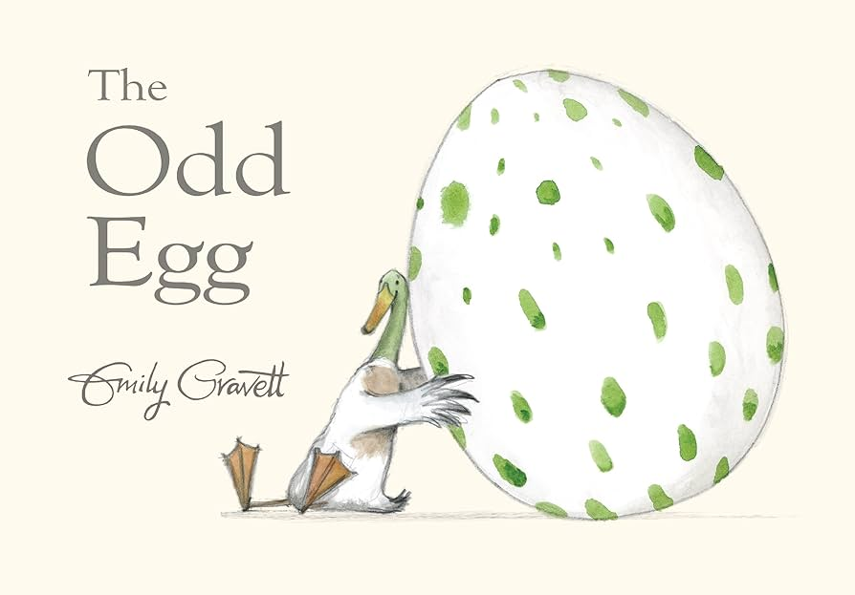
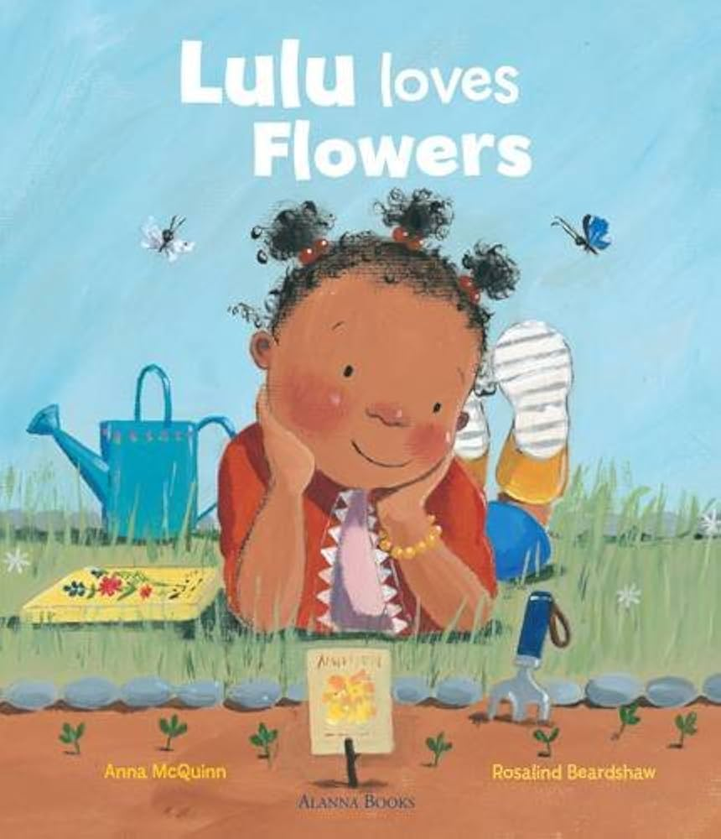

4
We will share a range of seasonal and festival-themed books including:
- The Odd Egg
- Lulu’s Garden
- Busy Spring
- Spot’s Easter
- We’re Going on an Easter Egg Hunt
Our Poetry Basket will include favourites such as 5 Little Ducks, 5 Little Peas and Sleeping Bunnies.

🌍 Understanding the World
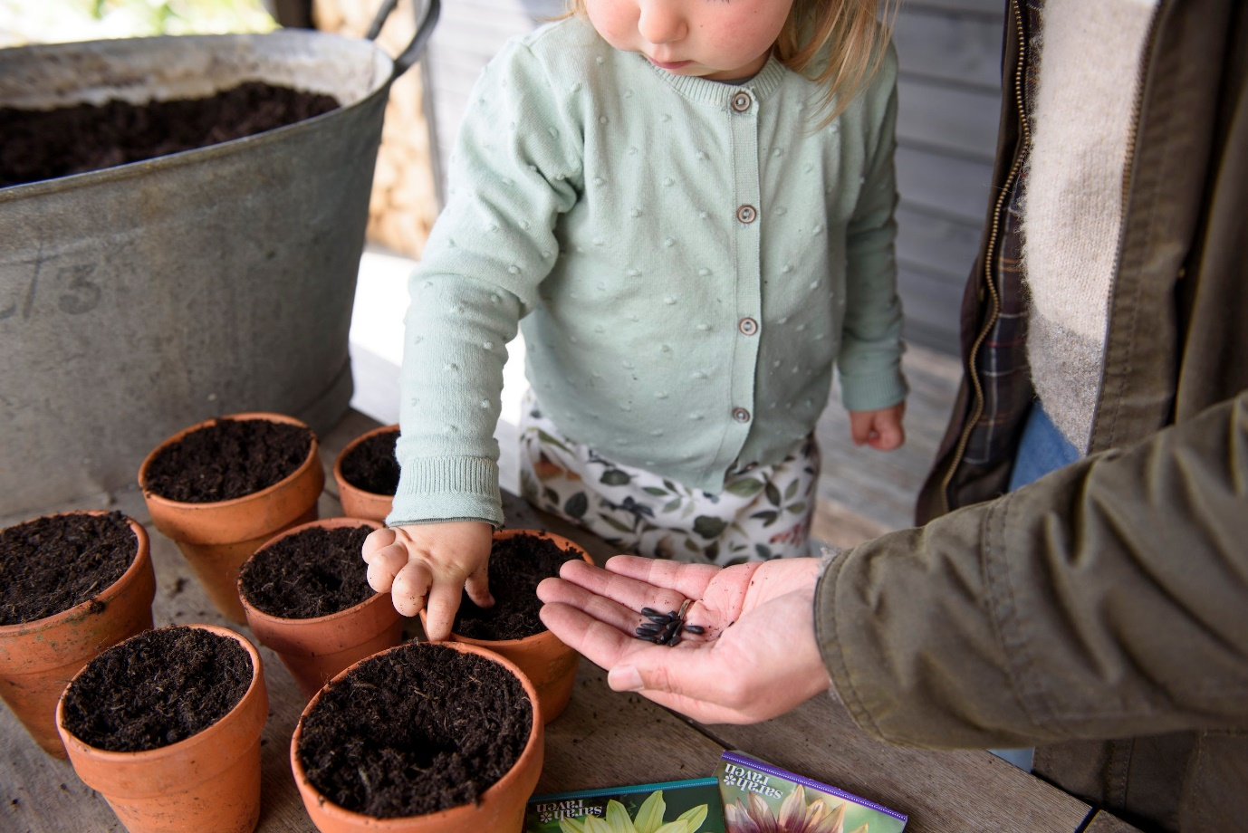
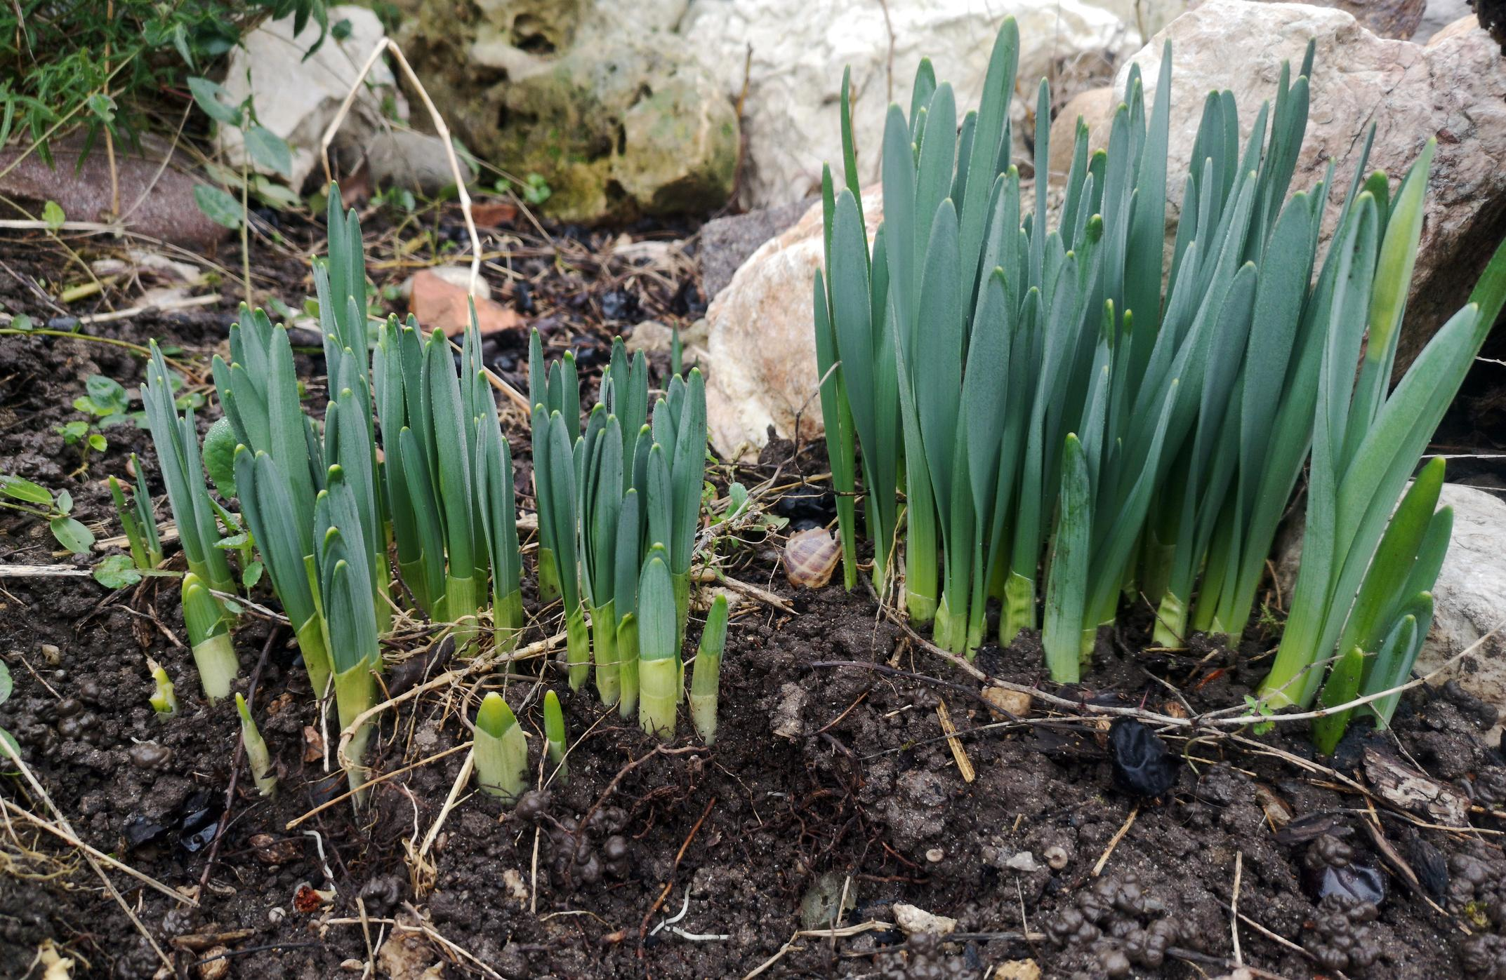

Children will:
- Observe plants growing in our nursery garden
- Use viewfinders to spot signs of Spring outdoors
- Learn about Ramadan, Holi, and Eid al-Fitr
- Welcome a visitor from the local community (Imam Zubair)
- Explore role play through Hats of Faith

🔢 Early Maths
Daily Morning Counting Club will focus on:
- Counting with one-to-one correspondence
- Saying number names in the correct order
- Understanding that the last number counted tells us “how many”
- Exploring “one more” and “one less”
Children will also explore puzzles, map-making and simple problem-solving activities.

🎨 Expressive Arts & Design
- Observational flower painting
- Spring crafts
- Mother’s Day card making
- Easter baking (melting chocolate and making egg nests)
- Creating treasure maps for our Easter egg hunt

💛 Personal, Social & Emotional Development
We will support children to:
- Re-settle after half term and revisit routines
- Take turns in conversations
- Initiate interactions with others
- Suggest ideas during play
- Show care and concern for living things

🏃 Physical Development
Children will:
- Develop fine motor skills through planting, crafting and baking
- Use tools that require twisting and turning
- Follow instructions independently

🌟 Special Events This Term
- World Book Day
- Mother’s Day
- Ramadan and Eid celebrations
- Holi festival
- Easter egg hunt
- Guinea pig visits

We are looking forward to a joyful and curiosity-filled half term as we explore the changes that Spring brings and celebrate new life and new beginnings together

