27th March 2026

Happy Easter
What a wonderful term, thank you to all our parents/carers and children for making it such a memorable term. We wish you all a fantastic Easter and look forward to welcoming you back into school on Tuesday 14th April.
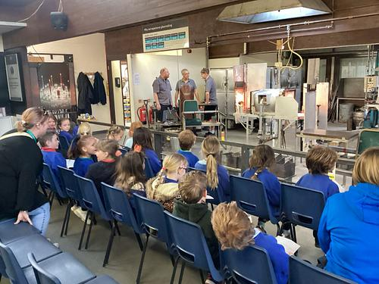
Local Memories, Broadening Horizons
What a fun-filled and fantastic week we’ve had! Turtles went on a fantastic trip to Langham Glass on Monday morning, not only did they get it see some really cool glass ornaments being made, they got to make their very own tealight! Such an interesting and interactive morning.
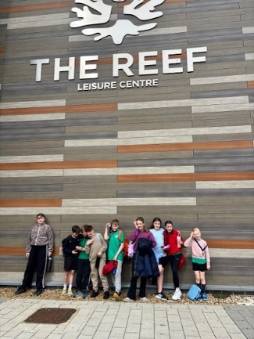
On Tuesday, we took 9 of our talented swimmers to the North Norfolk School Sports Partnership Swimming Gala at The Reef 🏊‍♂️. It was a fantastic morning of racing, teamwork, and determination, and we are so proud to have finished 5th out of 11 schools—a brilliant achievement! Special congratulations go to Hugh, Liv, Will, and Mollie, who each won 1st place medals—what a fantastic accomplishment!
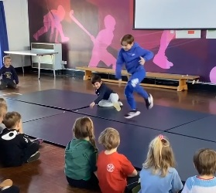
The whole school celebrated Sing Up Day on Wednesday 🎶, where we all came together in the hall for an uplifting performance of “We Get Up Again.” It was amazing to be part of something so special, joining thousands of schools across the UK and around the world. The atmosphere was full of joy and energy—such a memorable moment for everyone! A huge thank you to Mrs Furnell for organising this wonderful event.
We rounded off the week in style with our very own school talent show ⭐. With so many incredible acts signing up, we had to spread it across two afternoons just to fit everyone in! From singing and dancing to comedy and unique performances, the confidence and creativity on display were truly inspiring. Well done to everyone for making this week so special—what a great way to head into the Easter holidays.
Updated Wraparound Hours
Due to lack of uptake, we will no longer be offering wraparound until 6pm. We will still be offering the short (3.10 - 4.15pm) and medium length sessions (3.10pm - 5pm) and the after activity session (4/4.15 - 5pm). The 5 pm finish will still offer a hot meal. The prices will remain the same. Thank you for your understanding.

Extra - Curricular Clubs
We have lots of clubs running again this half term which is very exciting, all clubs will start the first week back. All after school clubs require SCOPAY permission and in some cases incur a small charge.
Lunch time:
Monday | BMX | Y3&4 (sign up on Scopay)
Tuesday | Warhammer | Y5&6
Wednesday | Orienteering | Y1-6
Thursday | Mixed Football | Y4-6
Friday | Handball  Film  Library/Book Club | Y4-6  Y5&6  All
After school:
Monday | Tennis | Y3-6 | 3.15-4.15
Tuesday | Archery | Y3-6 | 3.15 - 4.15 | £3.50 per session
Wednesday | Choir | Y3-6 | 3.15 – 4.00

SEND Parents Meetings – Wednesday 15th April
We will be holding our SEND parents’ meetings during the day on Wednesday 15th April, thank you to all parents who have returned their booking forms, these have all been returned informing you of your allocated time. If anybody id still to book an appointment please contact the school office.

FOBS
Easter Bingo: Thank you so much for all the Easter themed donations this morning, your support is always appreciated. We look forward to seeing you all on the 24th April for another fun evening of Bingo.

Good Work Awards/Values Awards
No Awards this week

Dates
27th March – Last Day of Term
14th April – School Starts
20th April – APHS Cluster Hockey Y4-6
21st April – NNSSP Y5 Dance/Cheerleading Workshop
24th April – FOBS Spring Bingo
18th May – APHS Cluster Tri Golf Y3&4
22nd May – Last Day of Term
1st June – School Starts
2nd June - NNSSP Cricket Y5&Y6
8th June – APHS Cluster Mini Tennis Y3&4
10th June - Burnham Wimbledon Y3&4
19th June – Summer Concert
24th June – Sports Day

1st – 3rd July - Transition
22nd June – APHS Cluster Cricket Y4-6
6th July – APHS Cluster Beach Volleyball Y5&6
17th July – Last day of Term

