3rd July 2026
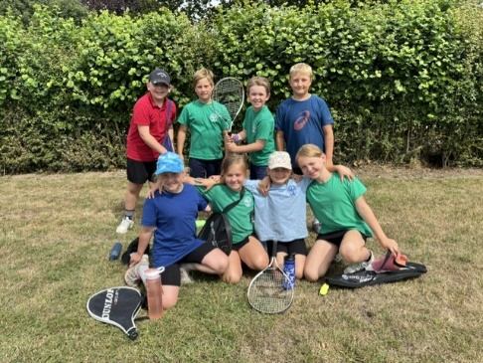
Local Memories, Broadening Horizons
What a fantastic week we've had at school, filled with achievement, adventure and plenty of memorable experiences! On Monday, eight of our Year 3 and 4 pupils represented the school at the APHS Cluster Mini-Tennis Tournament. They played brilliantly throughout the day, demonstrating excellent teamwork, determination and sportsmanship. We are delighted to announce that they were crowned tournament champions—a fantastic achievement. Well done to everyone involved!

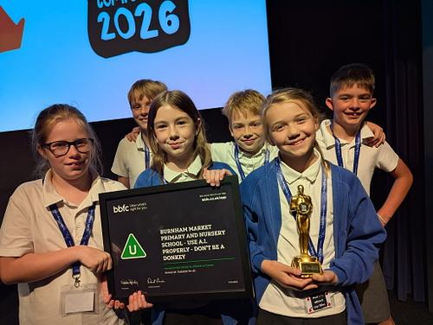
On Wednesday, six Year 5 pupils travelled to Disney Headquarters in London to attend the Childnet Film Awards. Their thought-provoking film explored the dangers of artificial intelligence and highlighted the importance of staying safe online. We were incredibly proud to see our pupils representing the school at such a prestigious event and celebrating their creative and important work.

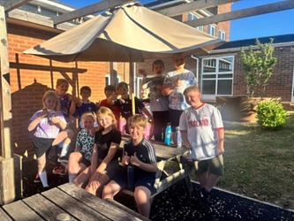
Throughout the week, children have taken part in a World Cup-themed orienteering challenge during their PE lesson. Pupils worked together to navigate the course, solve challenges and collect points for their teams. It was wonderful to see everyone enjoying being active while developing their teamwork and problem-solving skills.

To round off an exciting week, 12 Year 4 pupils enjoyed a fantastic camping experience on the school field on Thursday evening. The children had great fun pitching tents, taking part in activities, sharing stories and enjoying the outdoors with their friends. It was a brilliant evening filled with laughter, adventure and memories that will last a long time.

The latter part of the week has also been all about transition. Most of our Year 6 pupils have spent time at their new secondary schools, taking their next exciting steps towards September. Meanwhile, the children who remained in school enjoyed two transition days in their new classes, meeting their new teachers and beginning to settle into the routines for the next academic year. We were also delighted to welcome our new Reception intake for September. A huge thank you to all of the staff who gave up their time to make these opportunities possible. We are incredibly proud of all our pupils for their enthusiasm, resilience and excellent behaviour throughout another busy and successful week.

SpaceBop Premier – Tuesday 7th July
We're delighted to be hosting a public red-carpet premiere at Fakenham Central Cinema on 7th July, kindly supported by Active Fakenham. The entire cast and crew are invited to a private screening at 6:00pm, followed immediately by a public showing and a special question-and-answer session. It's going to be a truly exciting event, and we hope you can all join us to celebrate the incredible hard work, creativity, and dedication that has gone into making SPACEBOP a reality! We can't wait to see you there! Check out the trailer here:
https://www.youtube.com/watch?v=4jxuP40sMOE

Seal Class Trip to Scolt Head Island – Monday 6th July
On Monday Seal Class will be going on an exciting boat trip to Scolt head Island, courtesy of John and Emma Thompson and the Welcome Ferry. Details have been posted on ClassDojo, please make sure you give consent on SCOPAY.

Holkham Days – 8th & 9th July
It is almost time for our exciting beach and woodland days, delivered by Holkham Education Team. Children will need to have a packed lunch and drink for the day. Thank you to those that have ordered a school packed lunch. Seal and Turtle Classes will be going to the beach on Wednesday, children will need to wear PE kit and a sun hat and please ensure you have put sun cream on your child that morning.
Dolphin & Kittiwake Classes will be heading into the estate on Thursday 9th, where they will do the high ropes course, fire building, camp cooking, woodland craft and den building. All children need to wear long sleeves and trousers/joggers/leggings and a cap/sun hat.
Each class will be travelling to the beach by coach, arriving at 9.30am and departing at 2.30pm to return to school for the end of the school day, with the exception of our Year 6’s who will have the option to stay overnight at The Norfolk Brickyard Campsite! Thank you again to Tim and Catherine Zoll for providing this opportunity for our Y6 Pupils. Details regarding the overnight stay have been posted on the Kittiwake ClassDojo page.
Sports Day – Wednesday 15th July – 9.00am
The rearranged date for Sports Day is Wednesday 15th July. The same arrangements will still apply. Lunch that day will take place on the field, immediately after the races have finished, families are welcome to bring a picnic and join their child for lunch. The menu for school dinners is hotdog/veggie dog, wedges and veggie sticks followed by a chocolate cookie. Please order by Friday 10th July. No other options will be available that day. FOBS will be selling bacon butties for £3.50, drinks and cakes.

End of Year Celebration Assembly – 16th July 9am
As has become a tradition now, we’d like to welcome all parents and carers into school for our end of year assembly. Here we will celebrate sporting successes, film triumphs, flower show awards, attendance and many more wonderful achievements from the year. We’d love to welcome you along.

End of year reports
We are pleased to announce that we will be sending home electronic copies of the children’s end of school reports on Friday 10th July. If you would like an opportunity to discuss these with your child’s teacher, please do book an appointment directly with them for the following week. As you might have seen from the BBC News, SATs results have been delayed this year due to technical difficulties with the marking and so we will be sending these out on the 16th/17th July when we have received them.

Changes to FSM Eligibility - September 2026
From September 2026 there are significant changes to the eligibility criteria for Free School Meals. More information was posted on Dojo on Thursday 2nd July regarding the changes and how to apply if you feel you may be eligible.
As a reminder for current Y2 parents/carers, the universal FSM entitlement ends at the end of KS1, so if you feel your child may be entitled to continue to receive free school meals please check the eligibility criteria and make an application.

Wraparound Job Vacancies
As of September, we will have vacancies in our friendly and proactive wraparound team. Please see the links below for more information and how to apply:
https://mynewterm.com/jobs/144825/EDV-2026-BMPANS-97156
https://mynewterm.com/jobs/144825/EDV-2026-BMPANS-73658

FOBS
Sports Day: We will still be serving bacon butties, cakes and hot & cold drinks at sports day from 9am. Cash and card accepted. If any parents would like to make a cake/traybake we would very much appreciate it!!
Burnham Flower Show: We are looking forward to as many of you as possible joining us at 1pm outside The Hoste, dressed in Alice in Wonderland themed costumes, for this years Flower Show Float. Fancy dress judging will begin at 1.15pm and then the float will depart as part of the parade heading to the playing fields. Its always a wonderful occasion so please come and join us.
School Disco: Our school disco is on Thursday 16th July, in the school hall from 5.00 – 6.30pm. The cost is £2 per child, this includes unlimited squash (cash on the night please).
Good Work Awards/Values Awards
 | Good Work Award | Values Award
SEALS | Seal Class (because you have had a fabulous transition to Y1) | Seal Class (because you worked so well as a team to create some amazing art)
TURTLES | Maya (because of your fantastic and improved concentration) | Remy (because of how well you work in a partnership or a team)
DOLPHINS | Digby (because you have been very focused during transition) | Year 4 Campers (because of your teamwork and the way you supported each other during the camp out)
KITTIWAKES | Leah (because of your fantastic effort all week! Great motivation ahead of Y7) | The London Crew (fantastic motivation and respect! A great example of our wonderful pupils)

Dates
6th July – APHS Cluster Beach Volleyball Y5&6
6th July - Seal trip to Scolt Head
6th – 10th July – Burnham Overy Art Exhibition
7th July – SpaceBop Film Premier – 6pm Fakenham Cinema
8th July - Seals and Turtles Wells Beach Day delivered by Holkham Ed Team
9th July – Dolphins and Kittiwakes High Ropes and Forest School delivered by Holkham Ed Team
9th July - Y6 Overnight camp @ The Norfolk Brickyard
10th July – End of year reports out (SATs results are now not until 16th July)
11th July – Burnham Flower Show
15th July – Sports Day – 9.00am
16th July – End of year celebration assembly – 9.00am
16th July – Leavers lunch at The White Horse
16th July - FOBS Summer Disco 5-6.30
17th July - Y6 Leavers Assembly – 9.00am
17th July – Last day of term
Safeguarding Leads – Mrs Stroulger, Miss Clarke, Mrs Beck, Mrs Ireson and Mr Williams

